<https://www.youtube.com/watch?v=3CC4N4z3GJc&list=PLblh5JKOoLUICTaGLRoHQDuF_7q2GfuJF&index=50>



Today we're going to talk about the gradient boost machine learning algorithm.

Specifically we're going to focus on how gradient boost is used for regression.

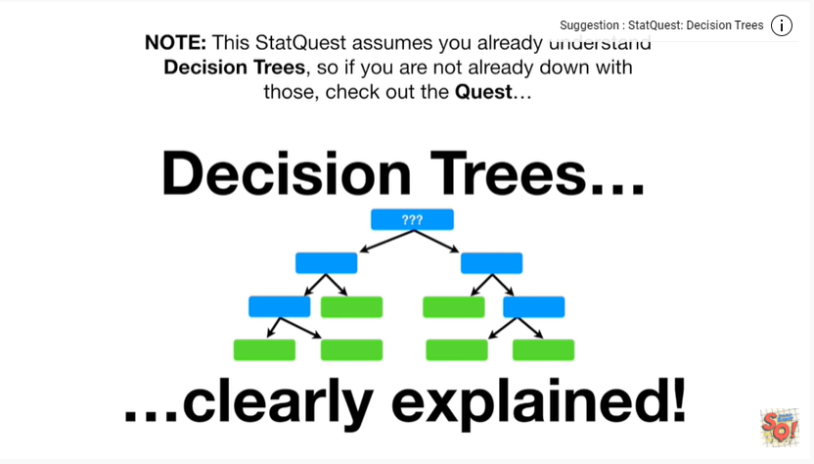

Note : this stat quest assumes you already understand decision trees, so if you're not already, down with those check out the quest.

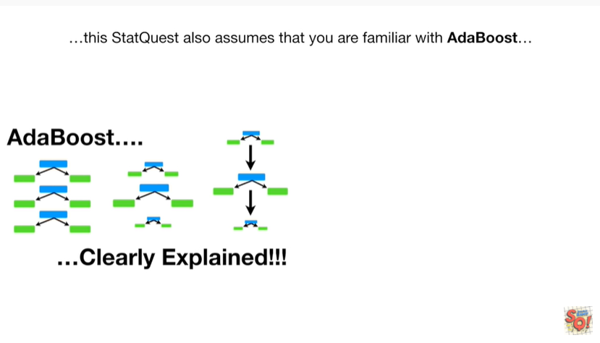

This stat quest also assumes that you are familiar with adaboost

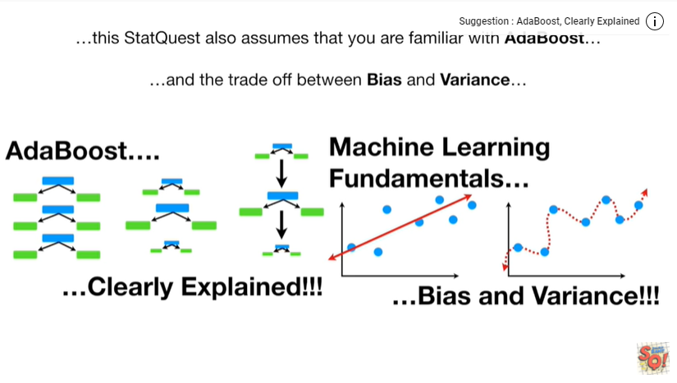

and the trade-off between bias and variance.

If not check out the quests, the links are in the description below.

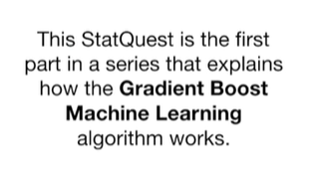

This stat quest is the first part in a series that explains how the gradient boost machine learning algorithm works.

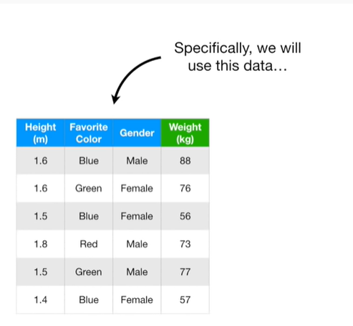

Specifically, we'll use this data

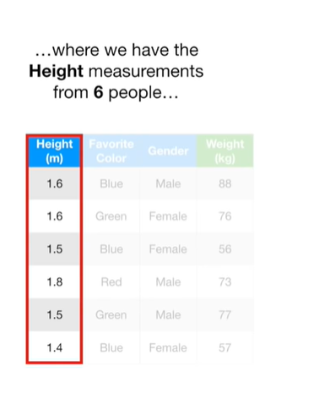

where we have the height measurements from six people

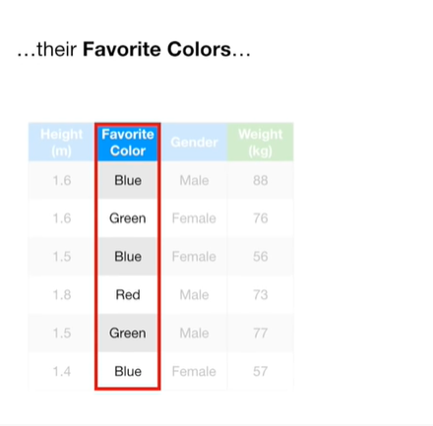

their favorite colors

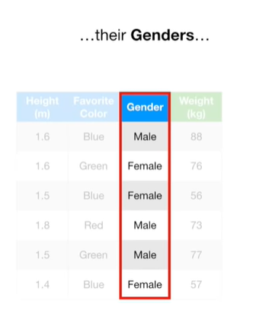

their genders

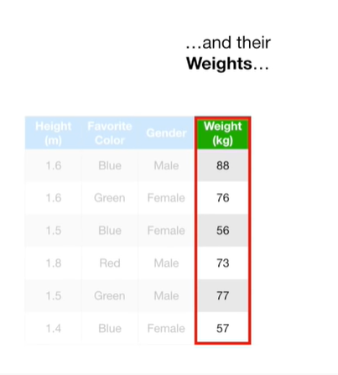

and their weights

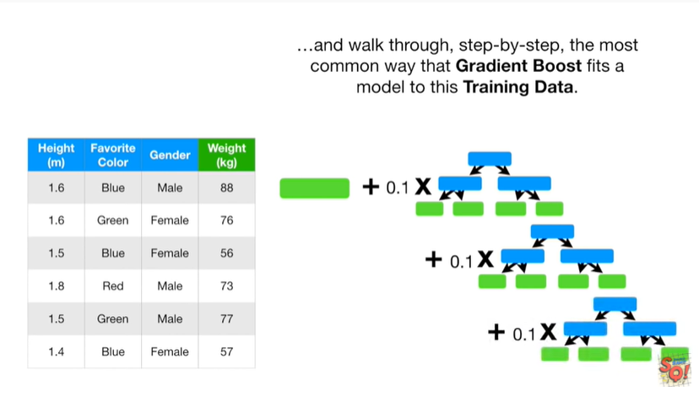

and we'll walk through, step by step, the most common way that gradient boost fits a model to this training data.

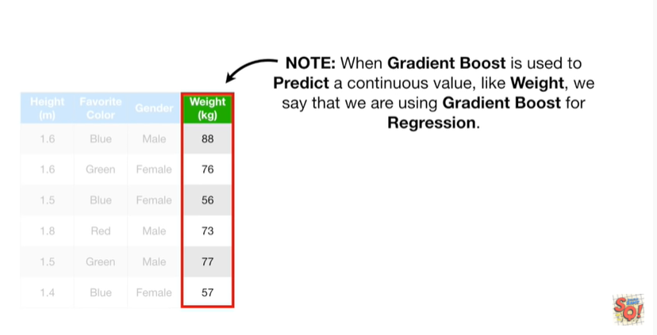

Note : when gradient boost is used to predict a continuous value, like weight, we say that we are using gradient boost for regression.

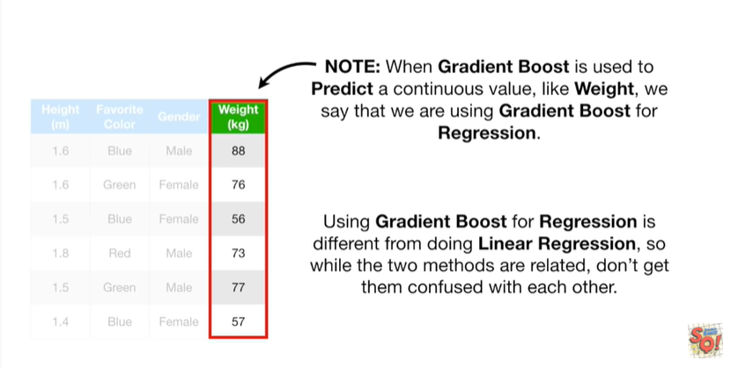

Using gradient boosts for regression is different from doing a linear regression, so while the two methods are related, don't get them confused with each other.

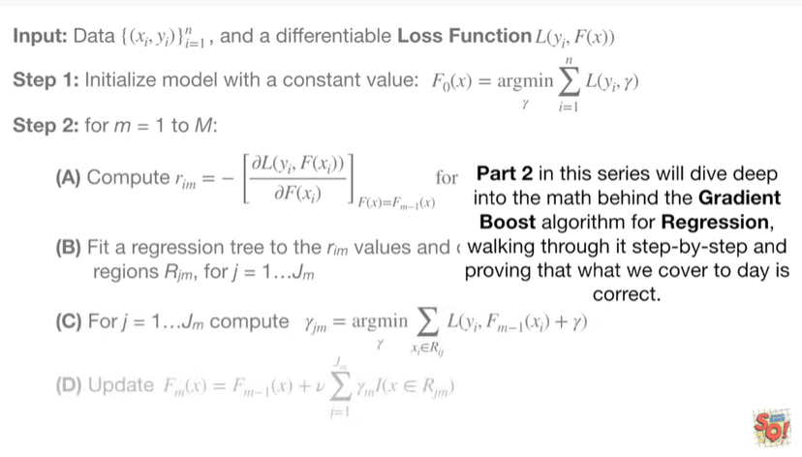

Part 2 : in this series we'll dive deep into the math behind the gradient boost algorithm for regression walking through it step-by-step and proving that what we cover today is correct.

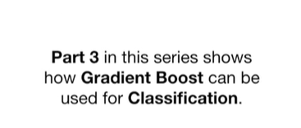

Part three in this series shows how gradient boost can be used for classification.

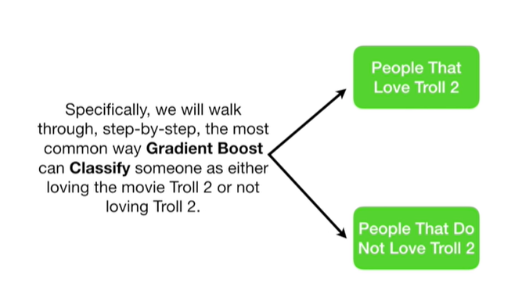

Specifically we'll walk through step by step the most common way gradient boost can classify someone is either loving the movie troll 2 or not loving troll 2.

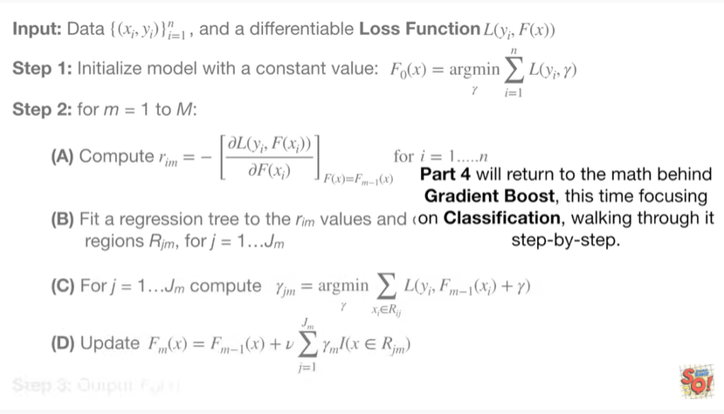

Part 4 we'll return to the math behind gradient boost this time focusing on classification walking through it step-by-step.

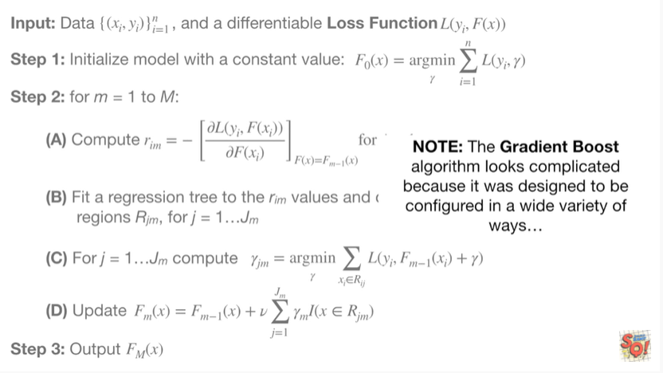

Note : the gradient boost algorithm looks complicated because it was designed to be configured in a wide variety of ways

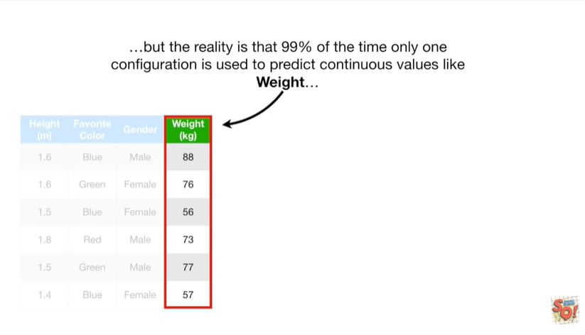

but the reality is that 99% of the time only one configuration is used to predict continuous values like weight

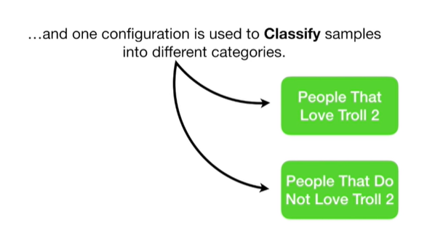

and one configuration is used to classify samples into different categories.

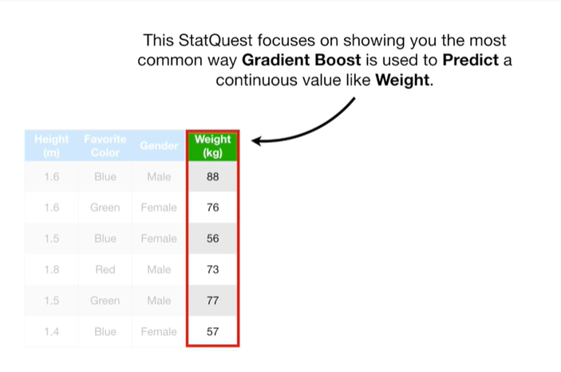

This stack quest focuses on showing you the most common way gradient boost is used to predict a continuous value like weight.



If you are familiar with adaboost then a lot of gradient boost will seem very similar.

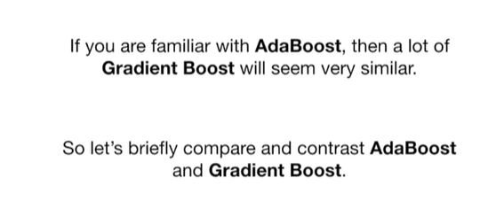

So let's briefly compare and contrast at a boost and gradient boost.

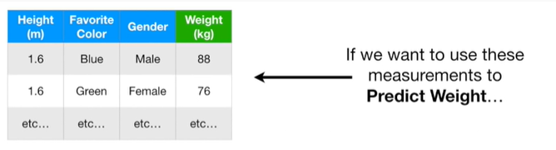

If we want to use these measurements to predict weight

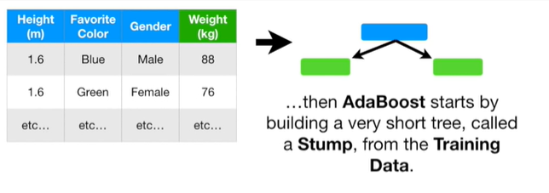

then adaboost starts by building a very short tree called a stump, from the training data.

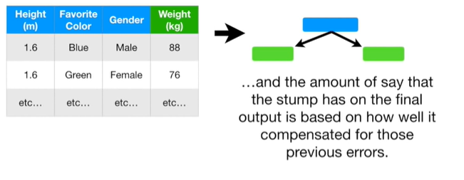

And then the amount of say that the new stump has on the final output is based on how well it compensated for those previous errors.

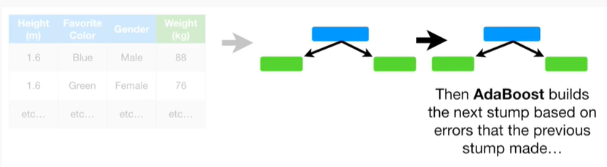

Then adaboost builds the next stomp based on errors that the previous stump made.

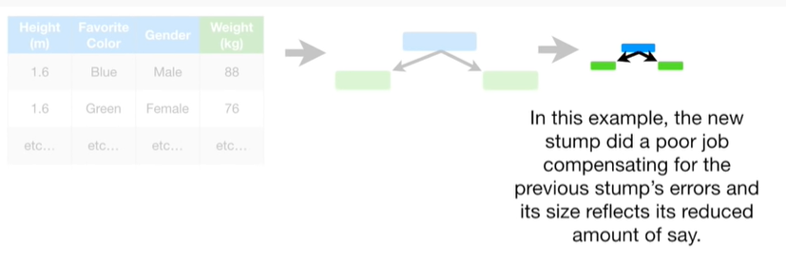

In this example, the new stump did a poor job compensating for the previous stumps errors and its size reflects its reduced amount of say.

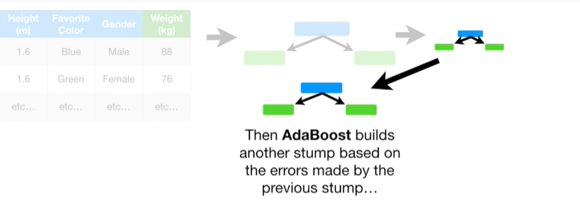

Then adaboost builds another stump based on the errors made by the previous stump

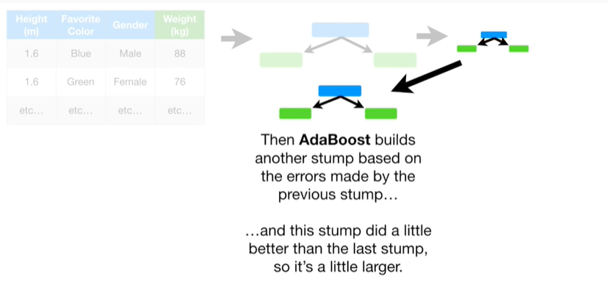

and this stump did a little better than the last stop so it's a little larger.

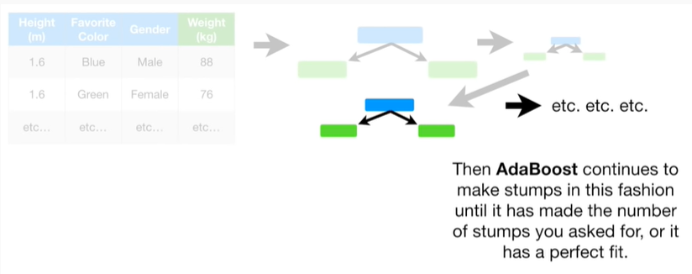

Then adaboost continues to make stumps in this fashion until it is made the number of stumps you asked for or it has a perfect fit.

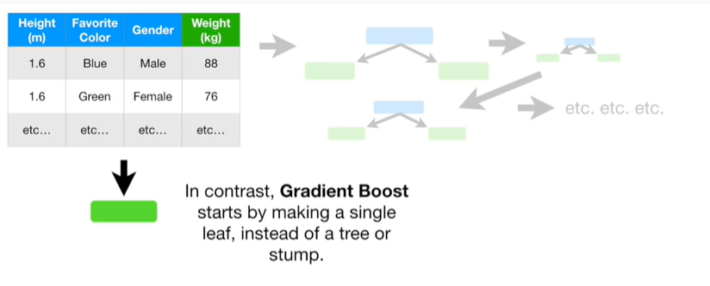

In contrast gradient boost starts by making a single leaf instead of a tree or stump.

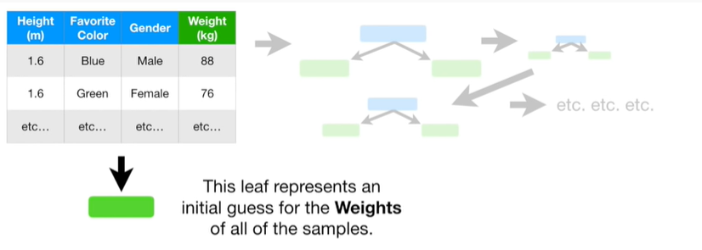

This leaf represents an initial guess for the weights for all of the samples.

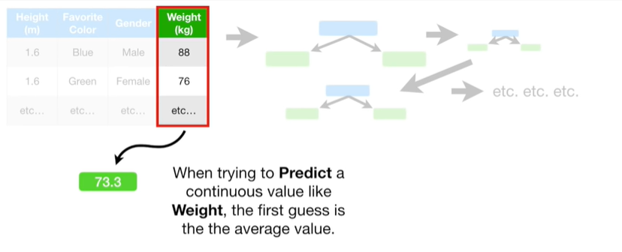

When trying to predict a continuous value like weight the first guess is the average value.

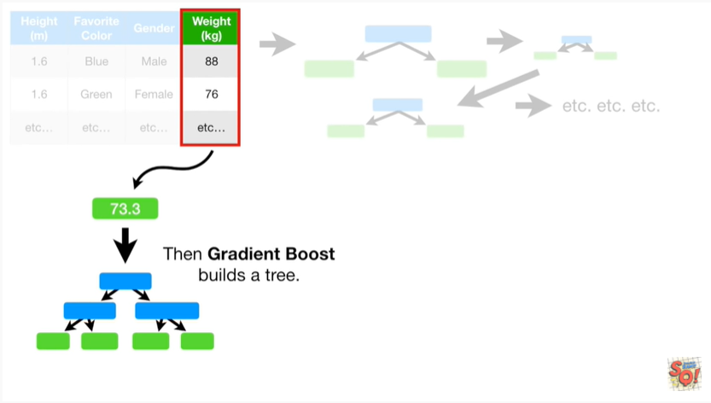

Then gradient boost builds a tree.

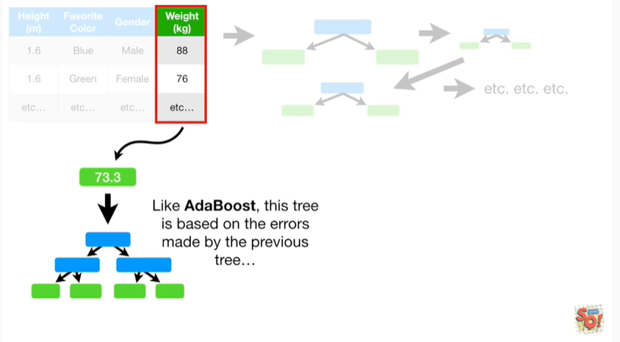

Like adaboost this tree is based on the errors made by the previous tree

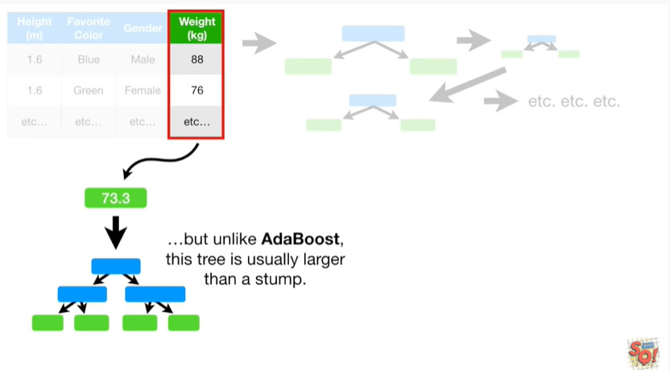

but unlike adaboost this tree is usually larger than a stump.

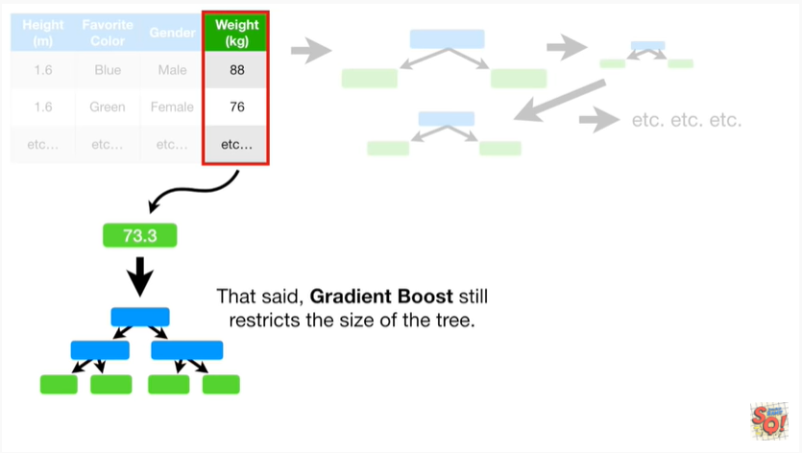

That said, gradient boost still restricts the size of the tree.

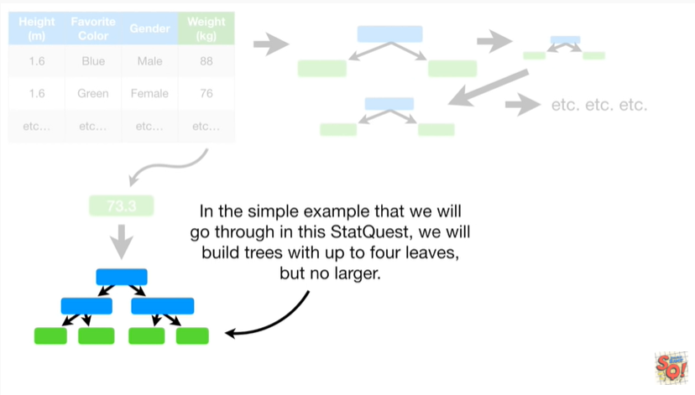

In the simple example that we will go through in this stat quest, we will build trees with up to 4 leaves but no larger.

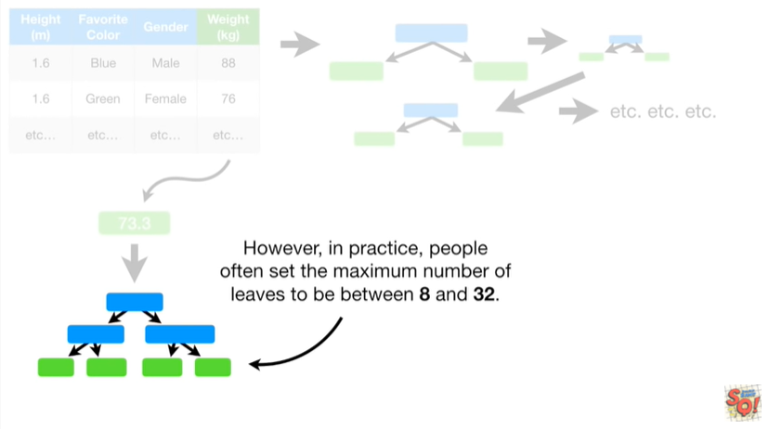

However, in practice, people often set the maximum number of leaves to be between 8 and 32.

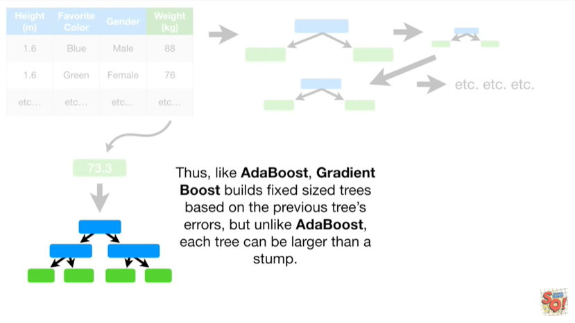

Thus like adaboost gradient boost builds fixed size trees based on the previous trees errors but unlike adaboost each tree can be larger than a stump.

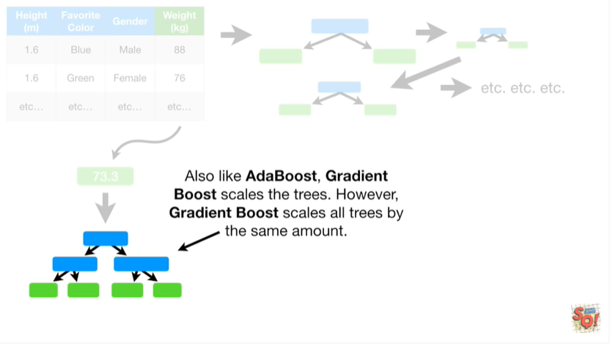

Also like adaboost, gradient boost scales the trees.

However, gradient boost scales all trees by the same amount.

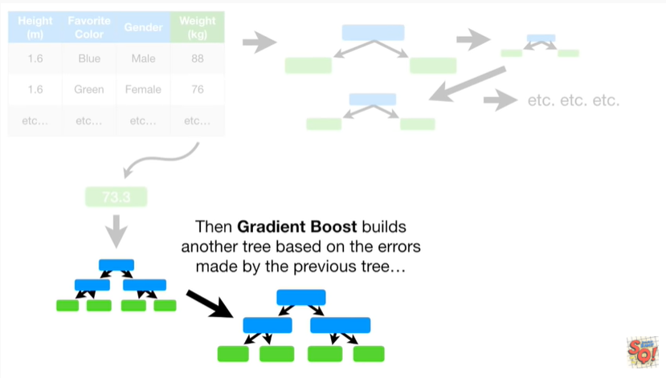

Then gradient boost builds another tree based on the errors made by the previous tree

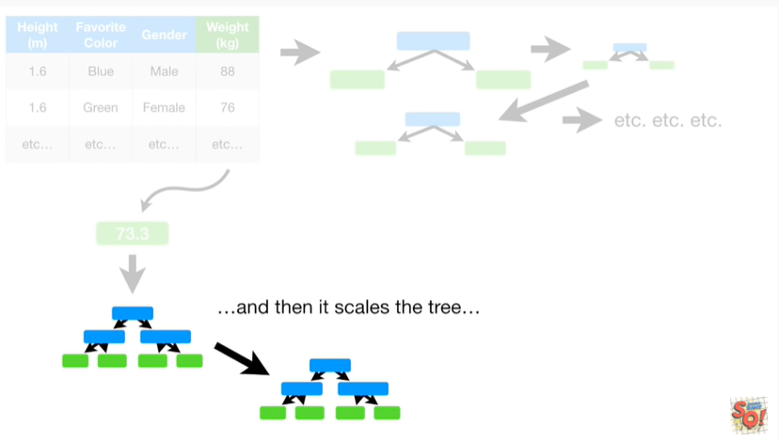

and then it scales the tree

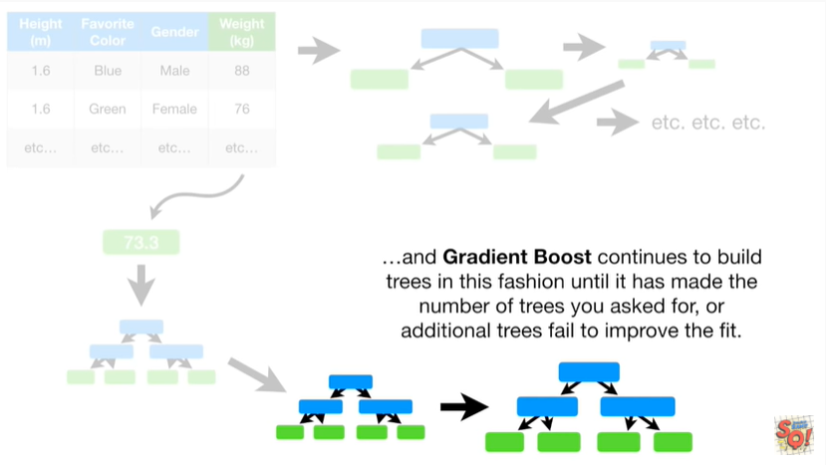

and gradient boost continues to build trees in this fashion until it has made the number of trees you asked fo,r or additional trees fail to improve the fit.

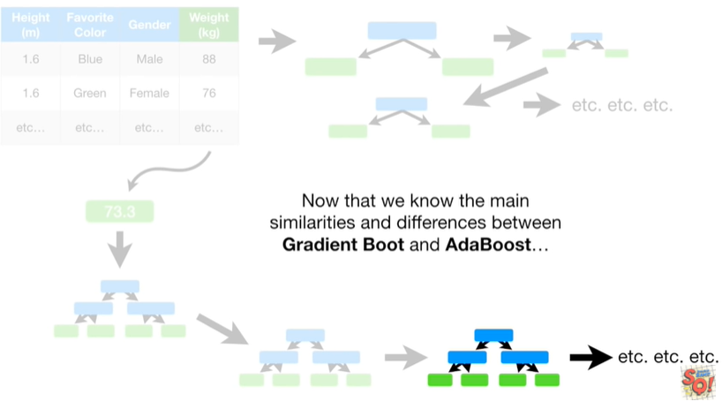

Now that we know the main similarities and differences between gradient boost and adaboost

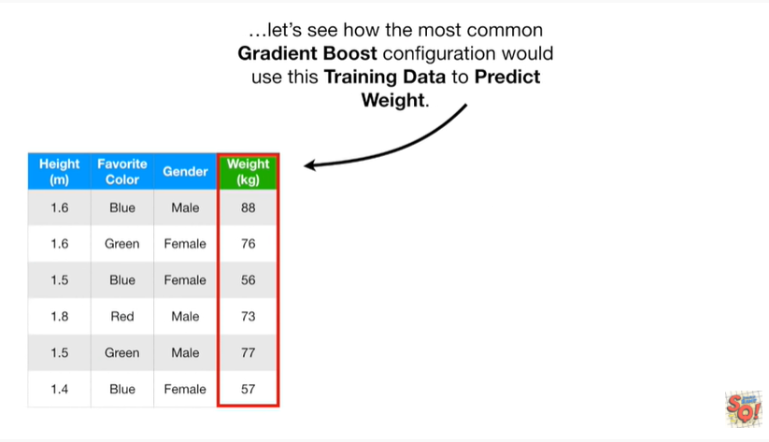

let's see how the most common gradient boost configuration would use this training data to predict weight.

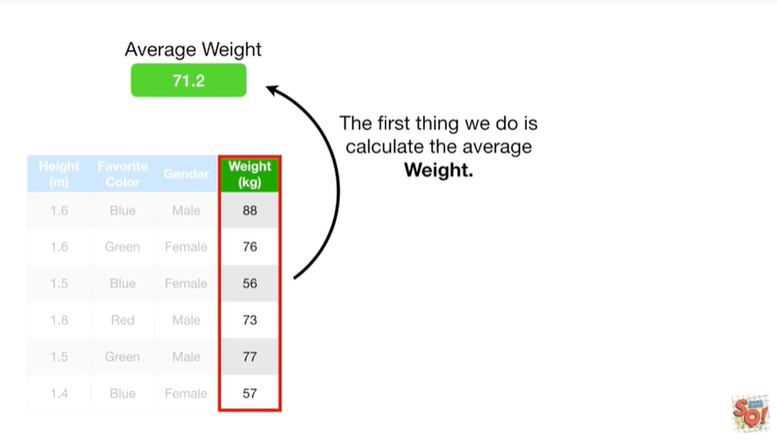

The first thing we do is calculate the average weight.

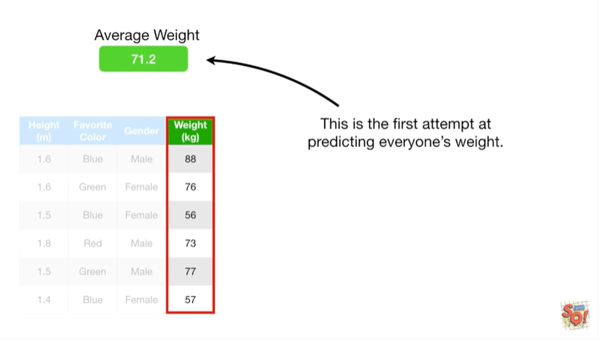

This is the first attempt at predicting everyone's weight.

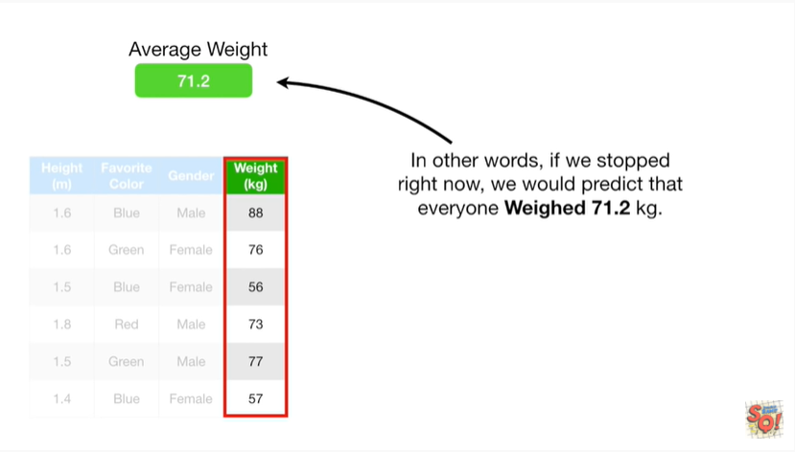

In other words, if we stopped right now we would predict that everyone weighed 70 1.2 kilograms.

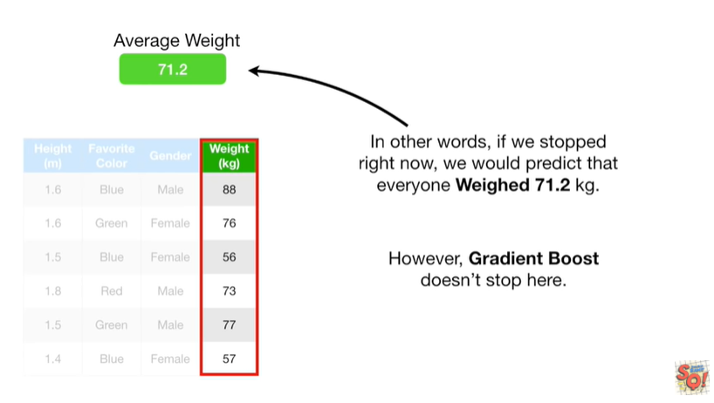

However, gradient boost doesn't stop here.

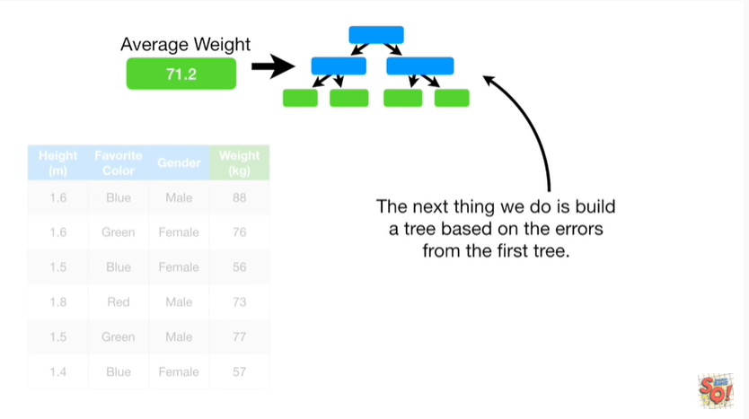

The next thing we do is build a tree based on the errors from the first tree.

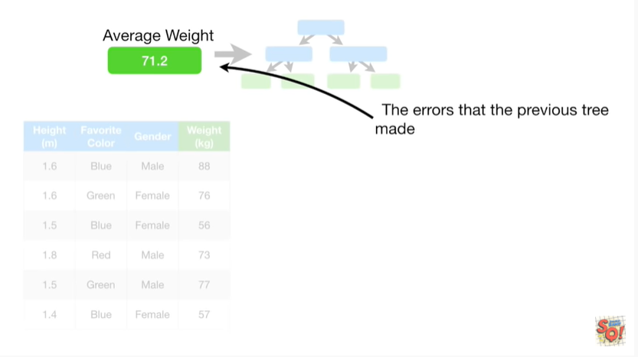

The errors that the previous tree made

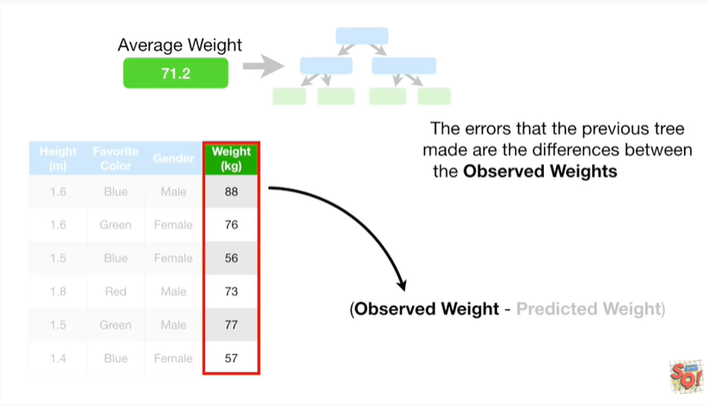

are the differences between the observed weights

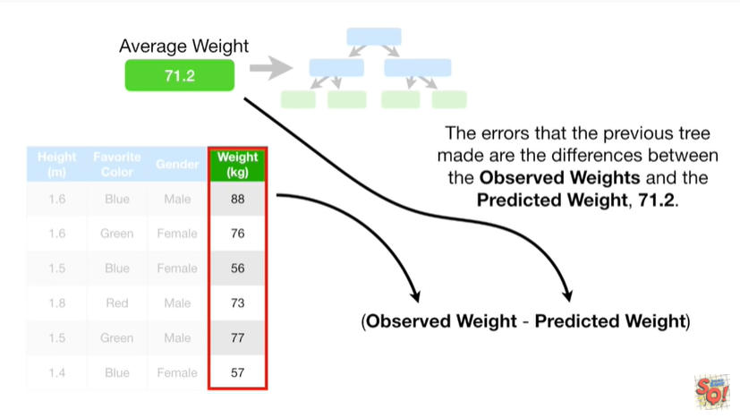

and the predicted weight 71.2.

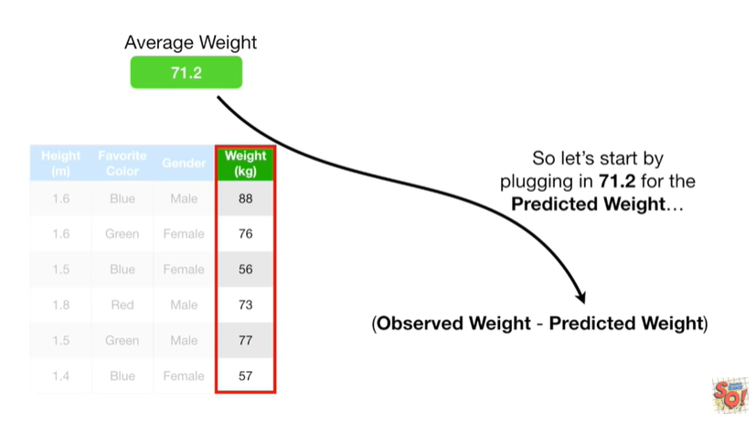

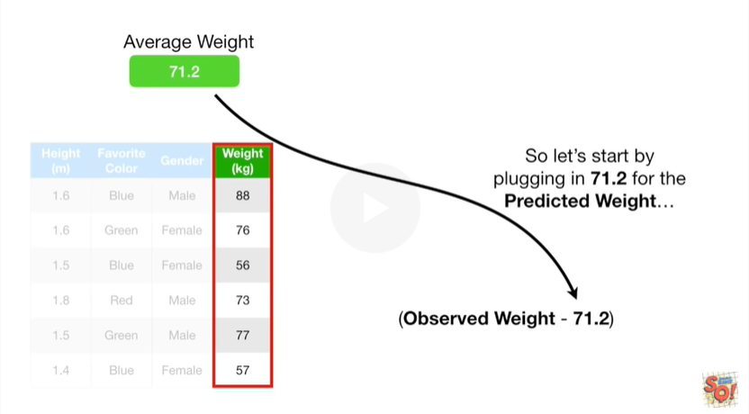

So let's start by plugging in seventy one point two for the predicted weight

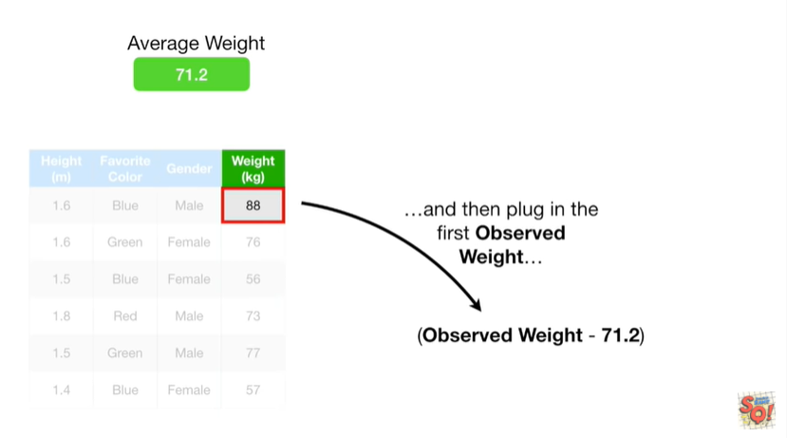

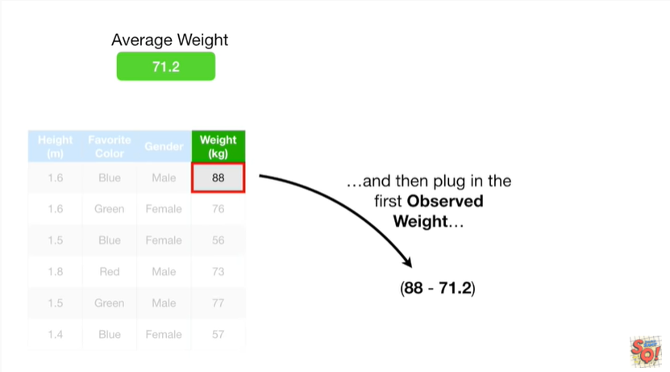

and then plug in the first observed weight

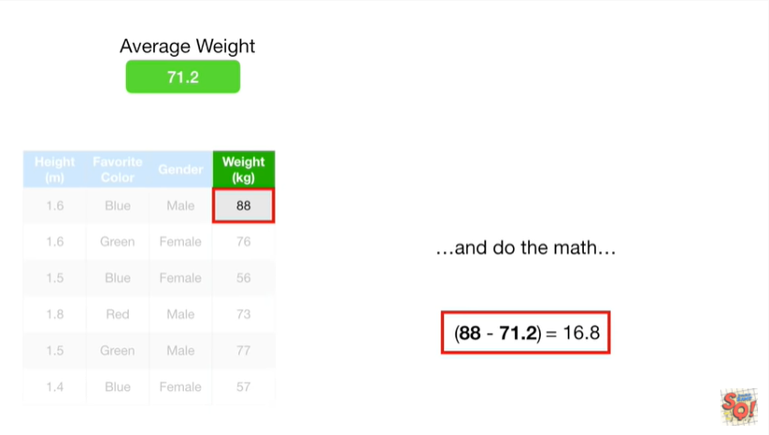

and do the math

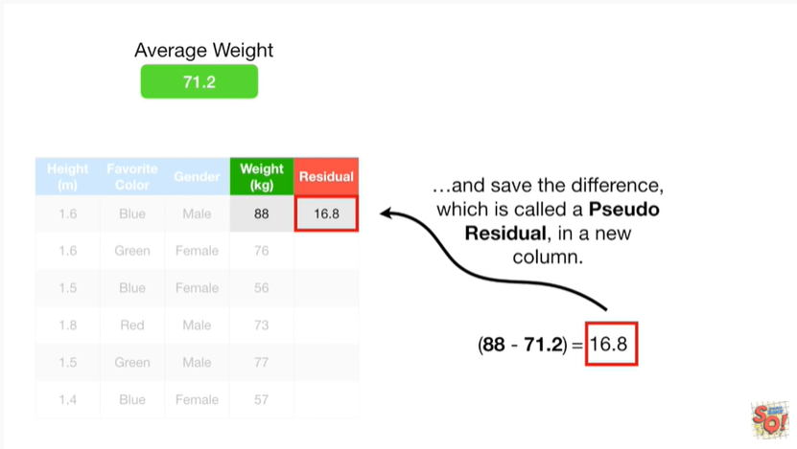

and save the difference which is called a pseudo residual in a new column.

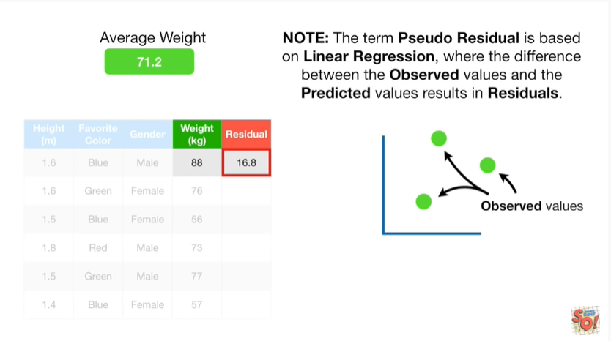

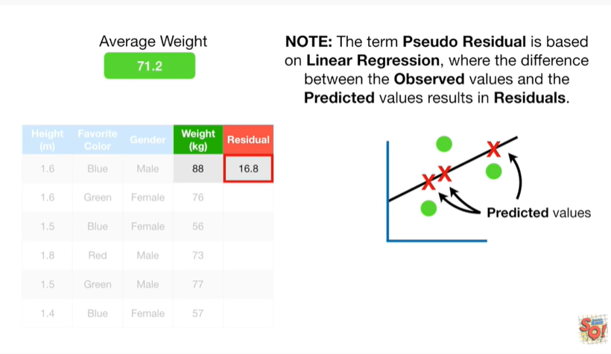

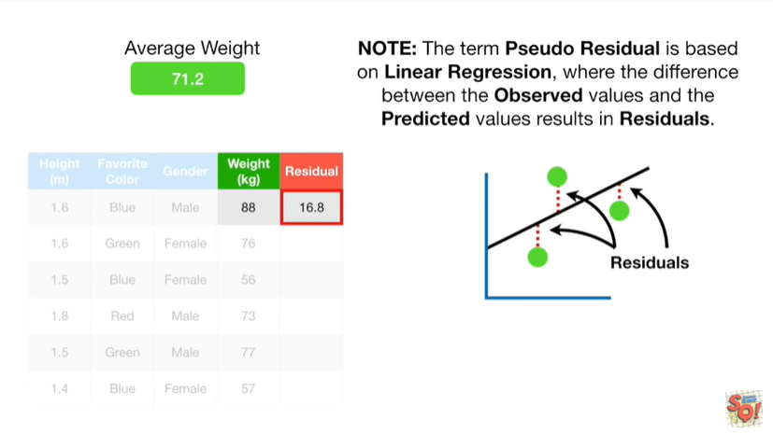

Note : the term pseudo residual is based on linear regression, where the difference between the observed values and the predicted values results in residuals.

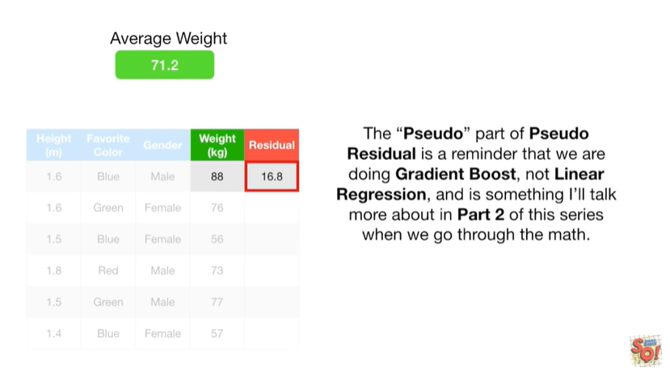

The pseudo part of pseudo residual is a reminder that we are doing gradient boost, not linear regression and is something I'll talk more about in part 2 of this series when we go through the math.

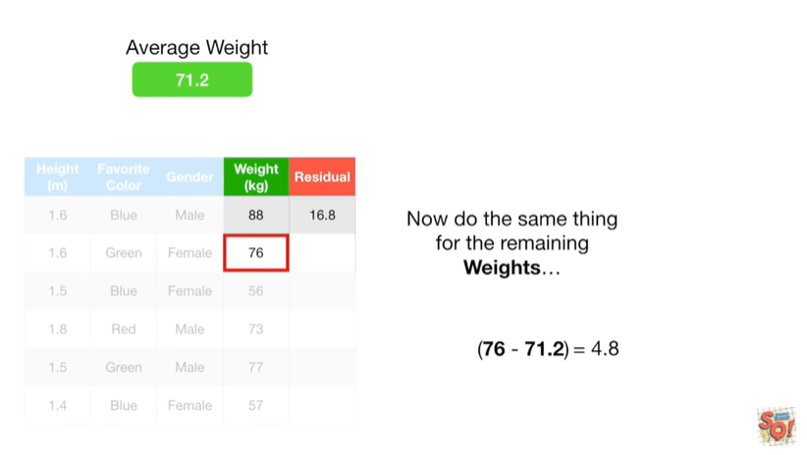

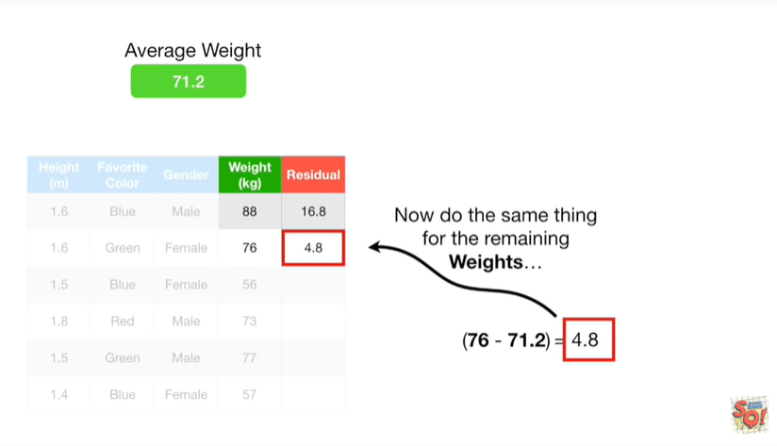

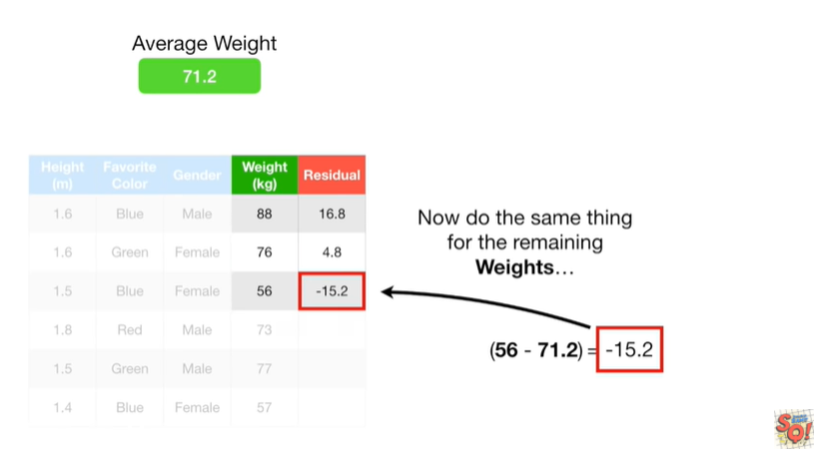

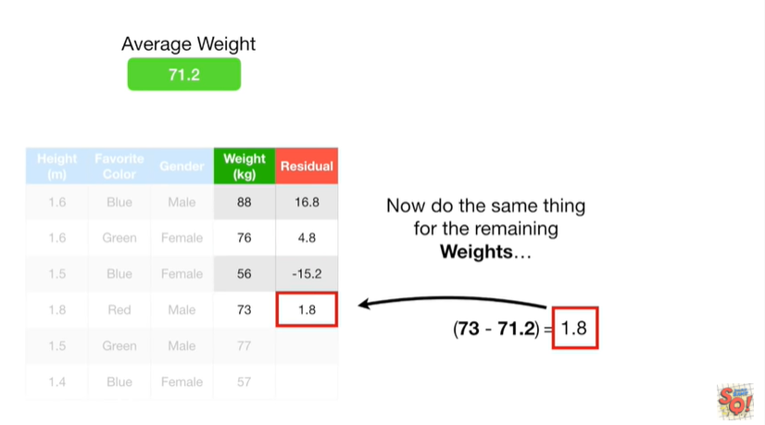

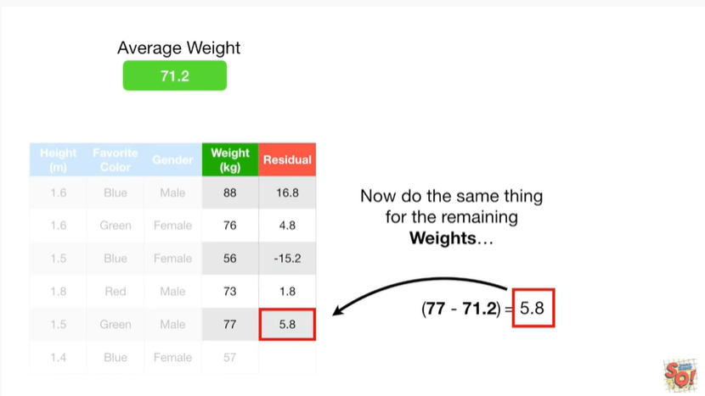

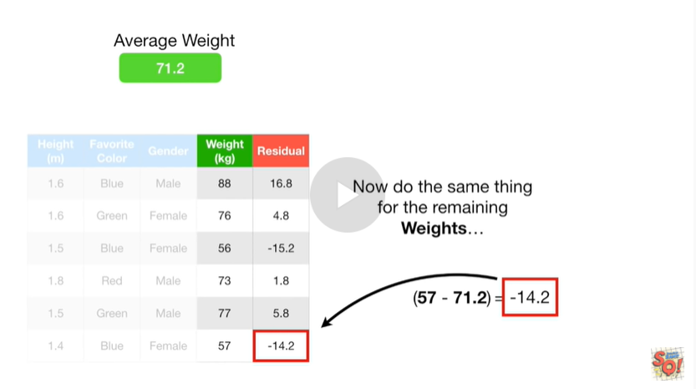

Now we do the same thing for the remaining weights.

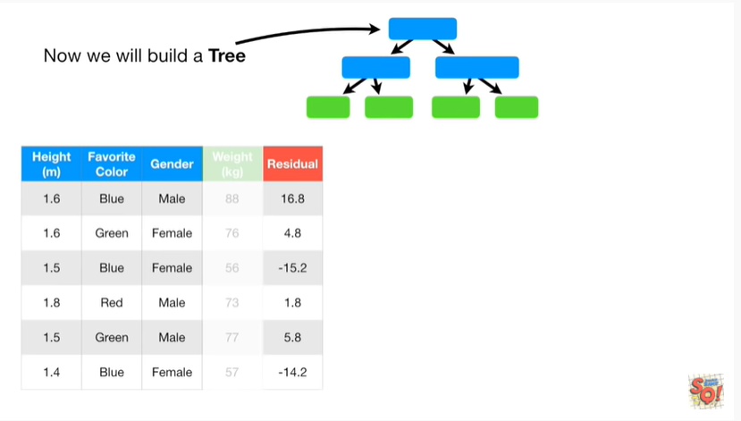

Now we will build a tree, using height.

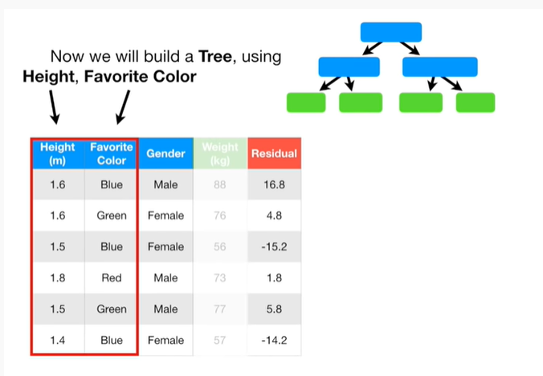

Favorite color

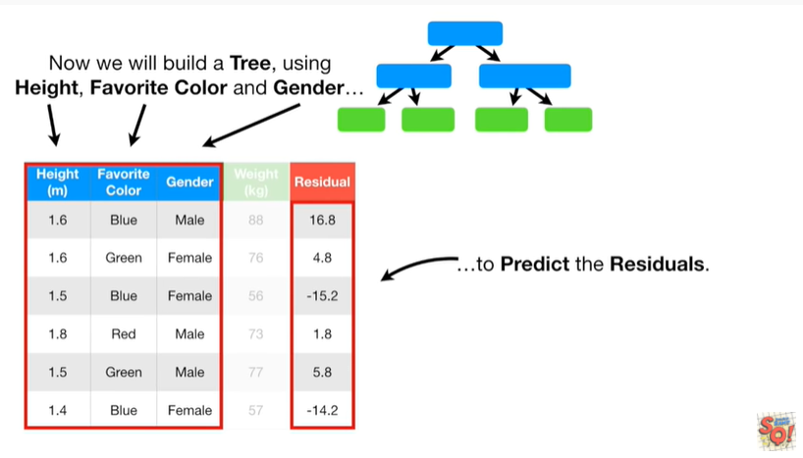

and gender to predict the residuals.

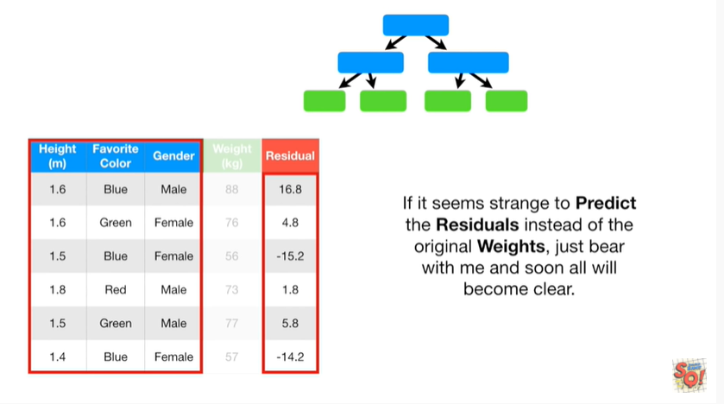

If it seems strange to predict the residuals instead of the original weights, just bear with me and soon all will become clear.

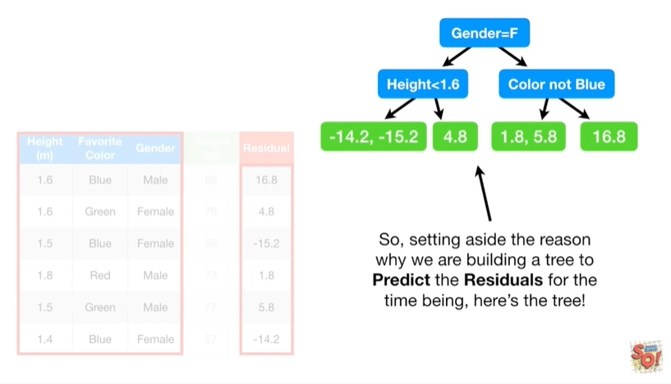

So setting aside the reason why we are building a tree to predict the residuals for the time being, here's the tree !

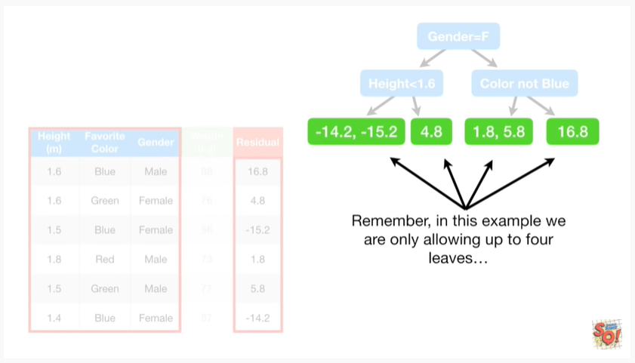

Remember, in this example we are only allowing up to four leaves

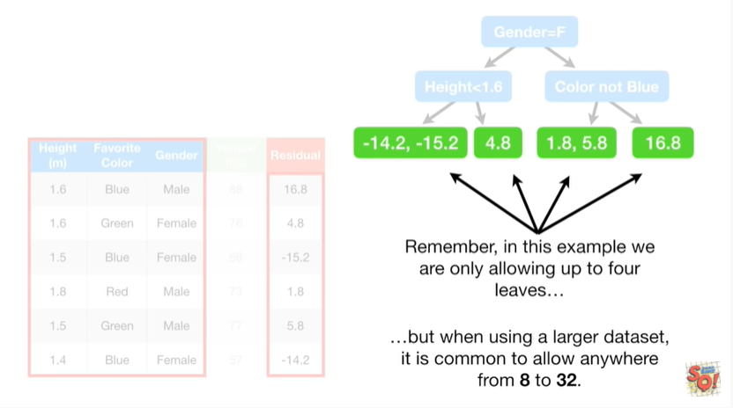

but when using a larger data set it is common to allow anywhere from 8 to 32.

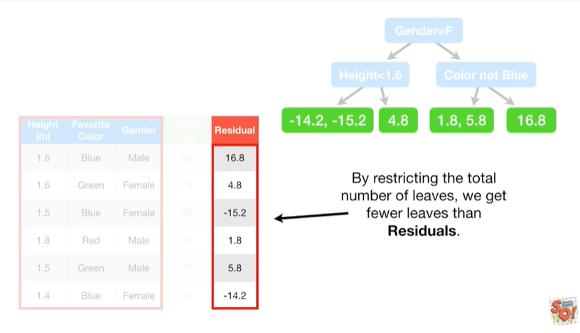

By restricting the total number of leaves we get fewer leaves than residuals.

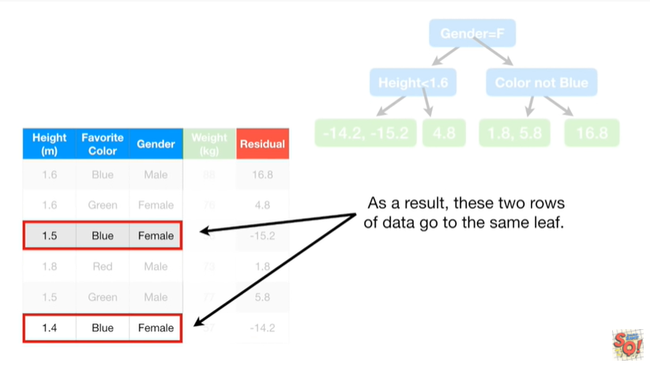

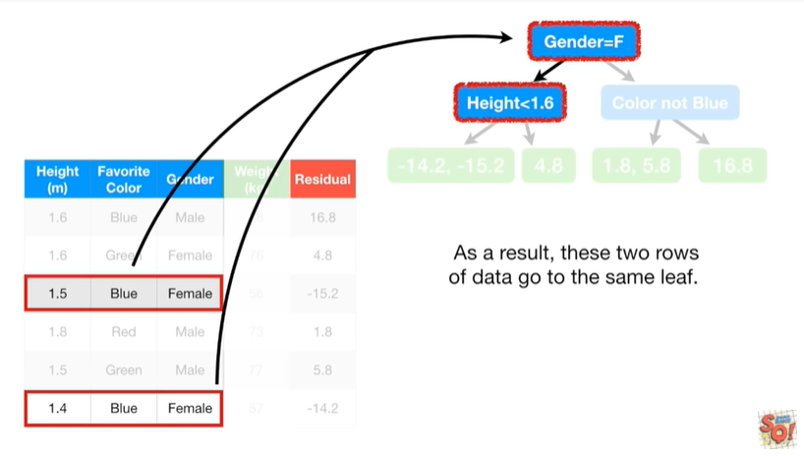

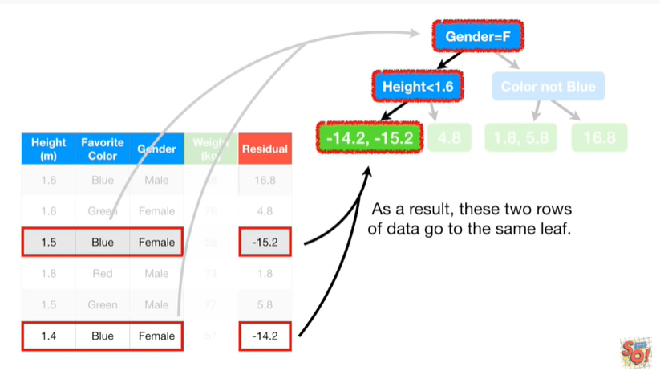

As a result these two rows of data go to the same leaf.

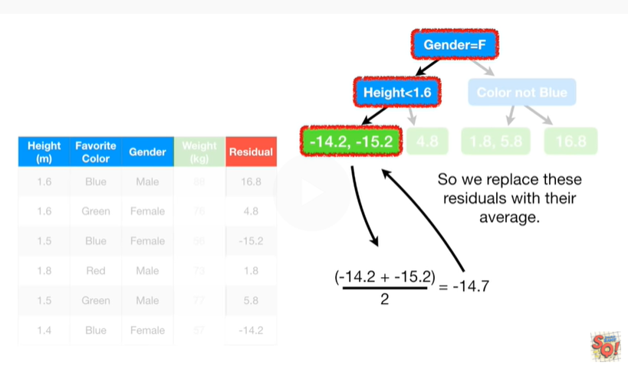

So we replace these residuals

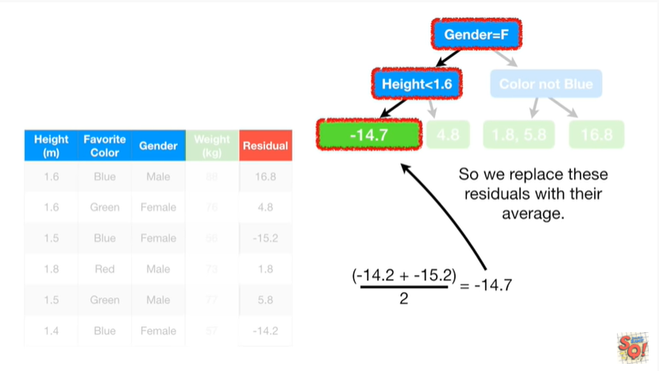

with their average.

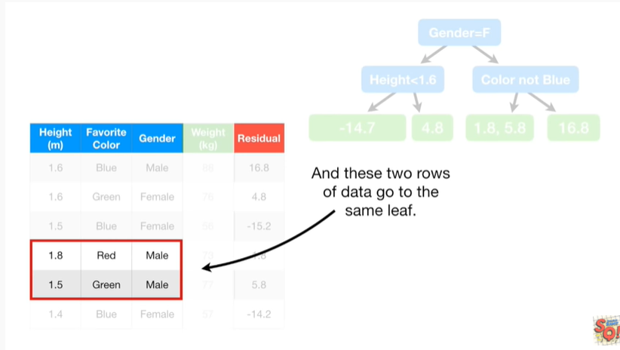

And these two rows of data

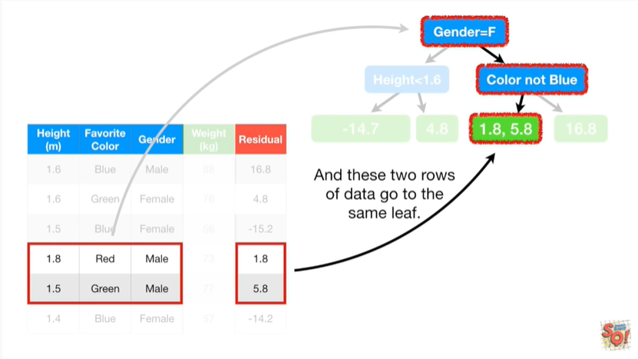

go to the same leaf.

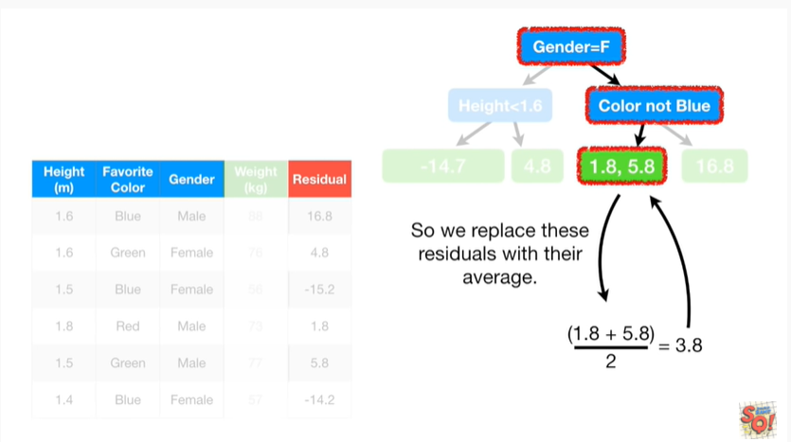

So we replace these residuals

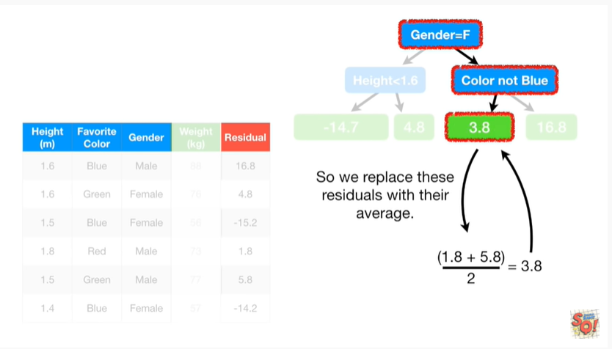

with their average.

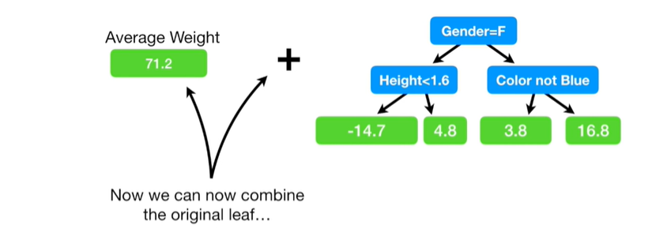

Now we can combine the original leaf

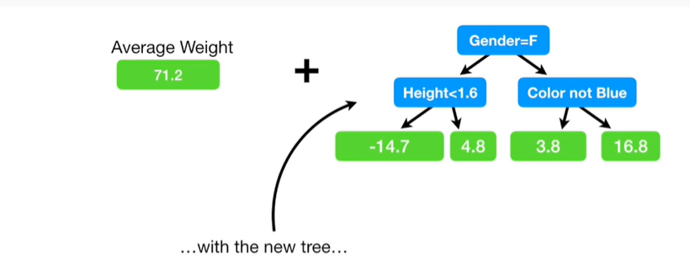

with the new tree

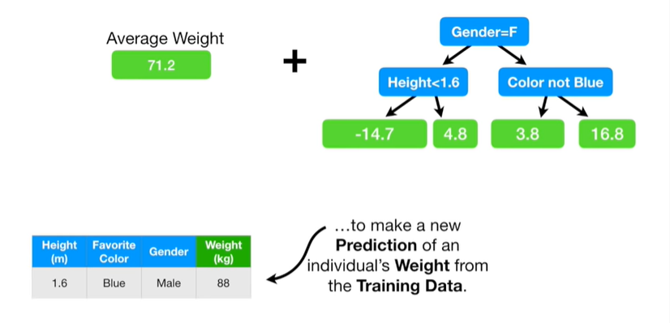

to make a new prediction of an individual's weight from the training data.

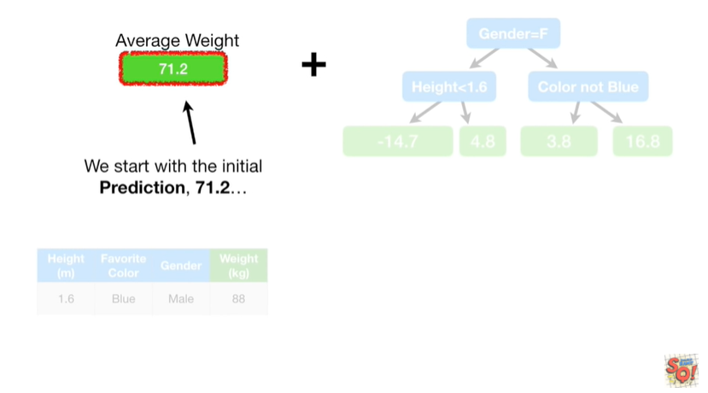

We start with the initial prediction seventy one point two

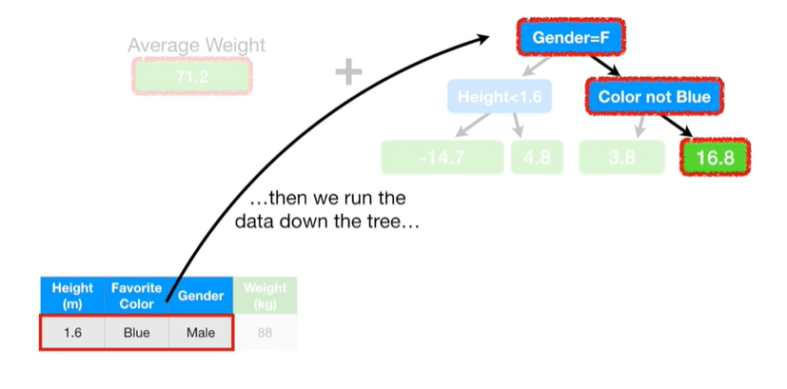

then we run the data down the tree

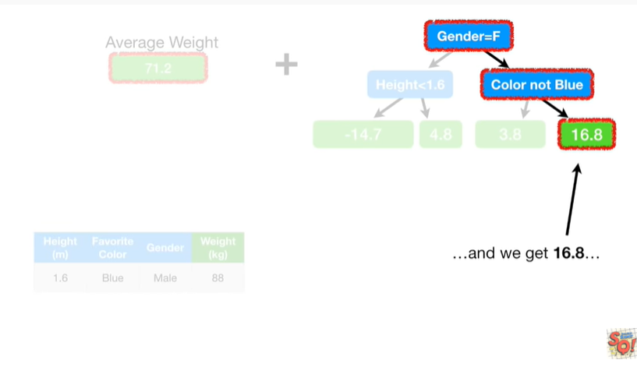

and we get sixteen point eight

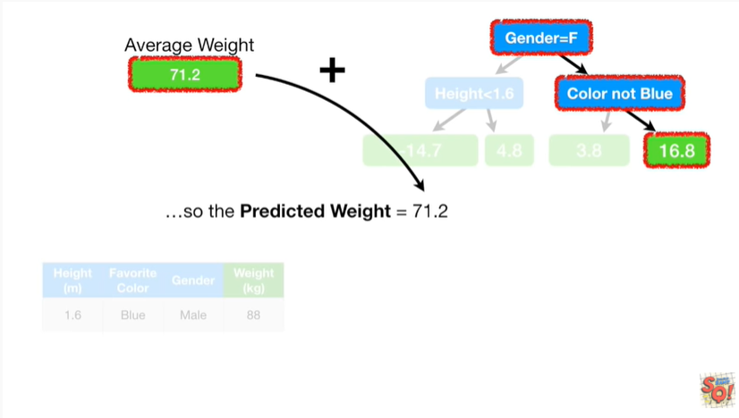

so the predicted weight equals seventy one point two

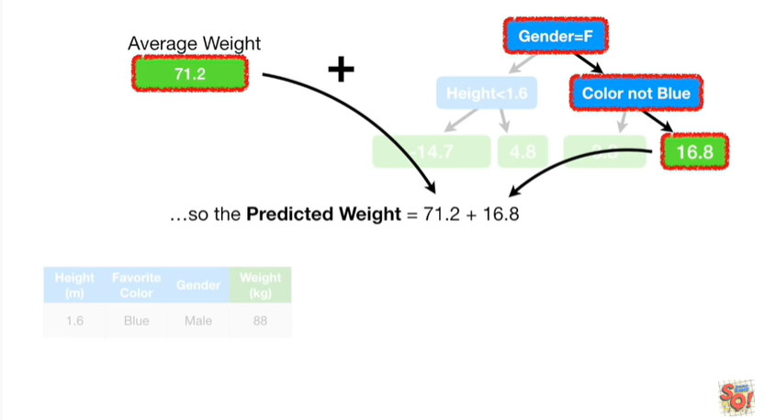

plus sixteen point eight

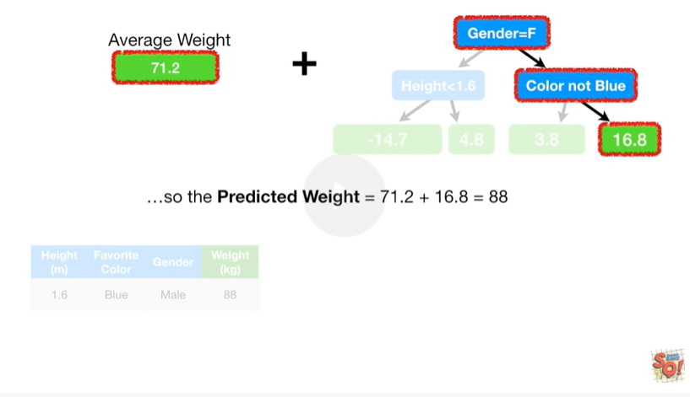

which equals eighty eight

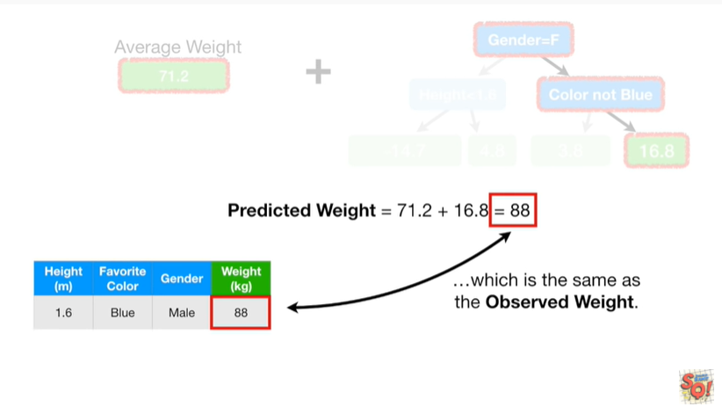

which is the same as the observed weight.

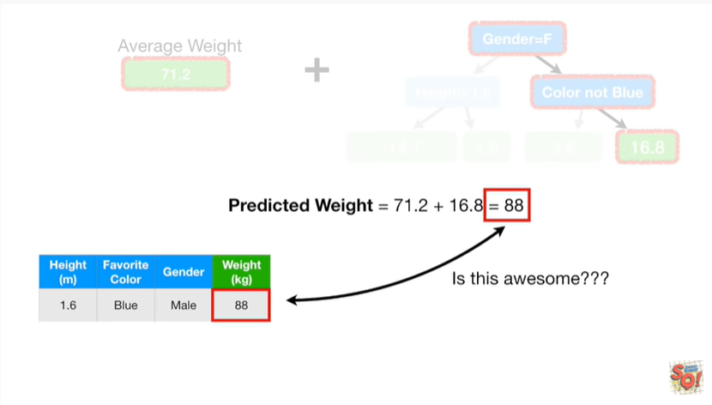

Is this awesome ?

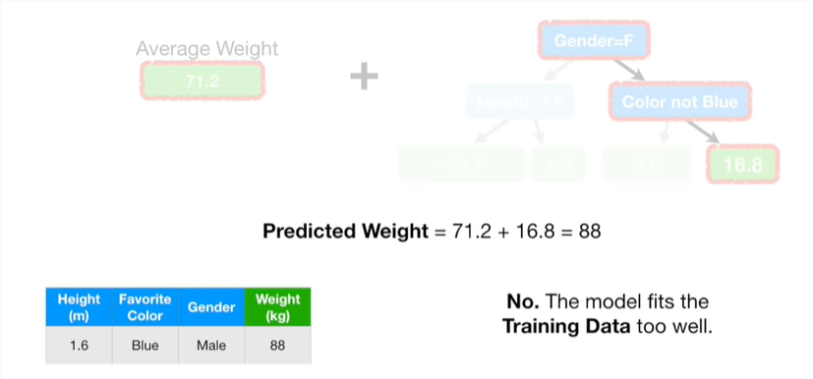

No.

The model fits the training data too well.

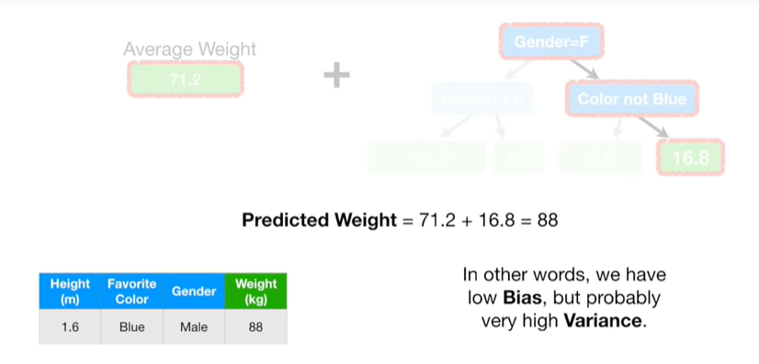

In other words we have low bias but probably very high variance.

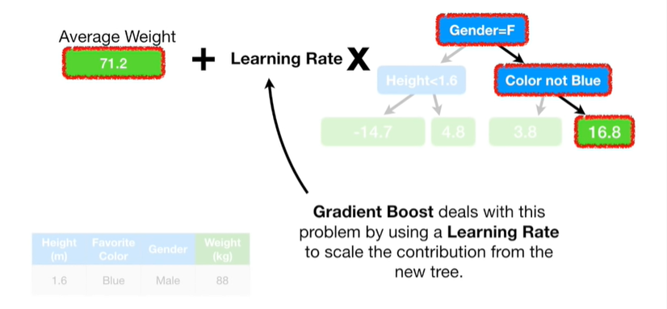

Gradient boost deals with this problem by using a learning rate to scale the contribution from the new tree.

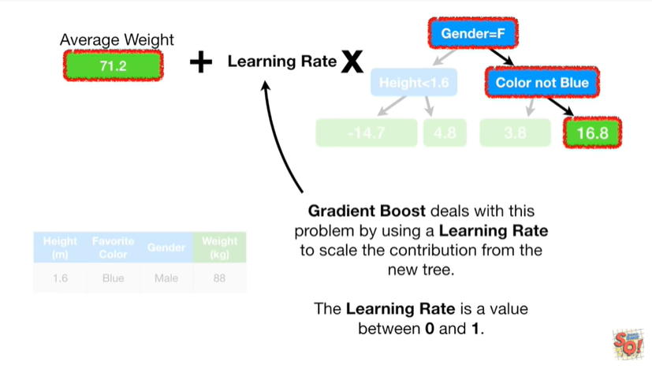

The learning rate is a value between zero and one.

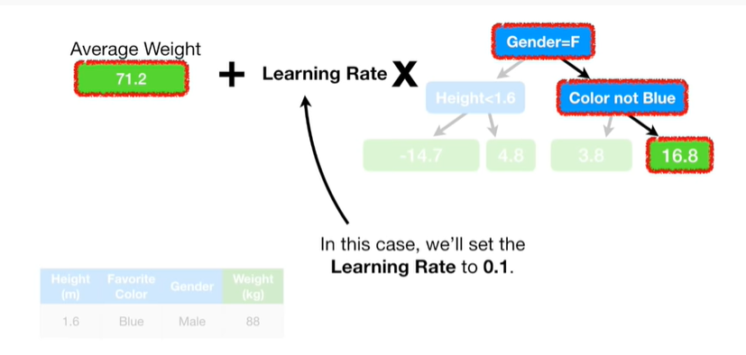

In this case we'll set the learning rate to 0.1.

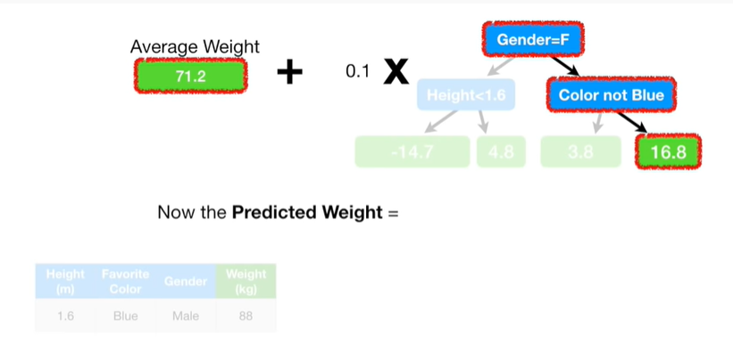

Now the predicted weight equals

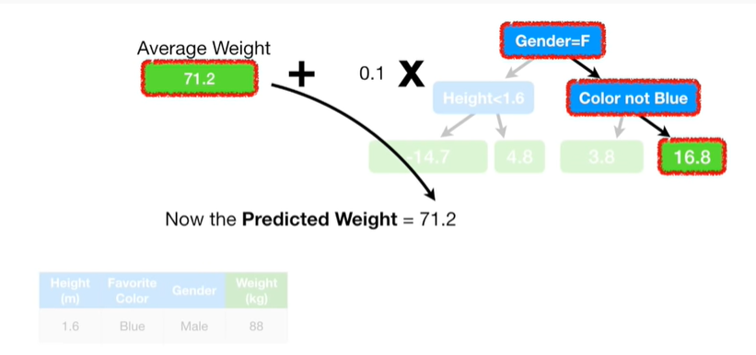

seventy one point two

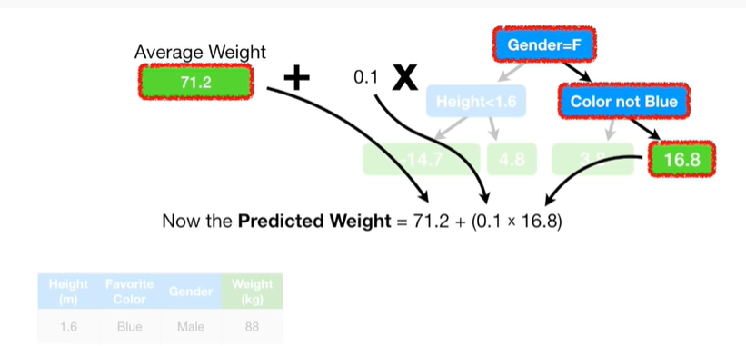

plus zero point one times sixteen point eight

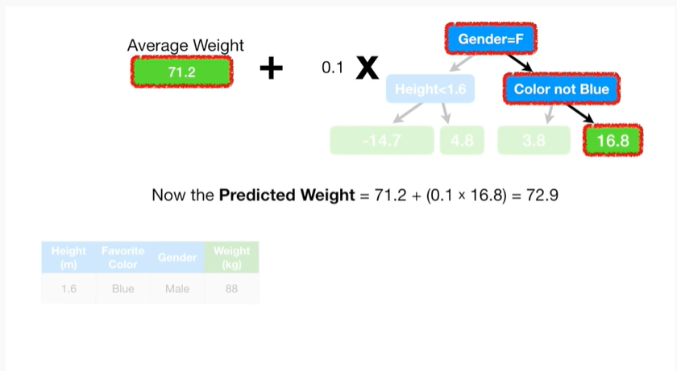

which equals seventy two point nine.

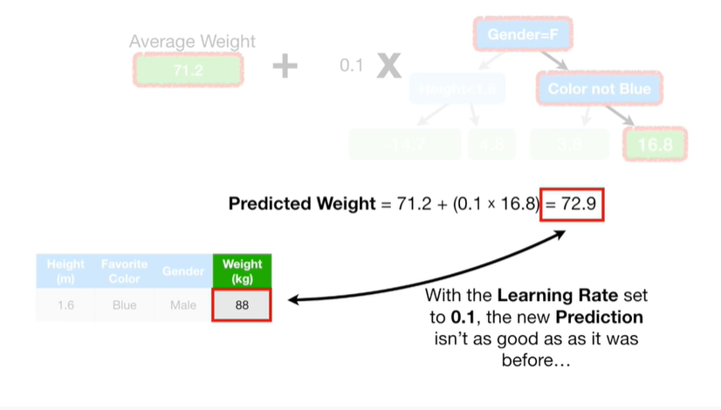

With the learning rate set to 0.1, the new prediction isn't as good as it was before

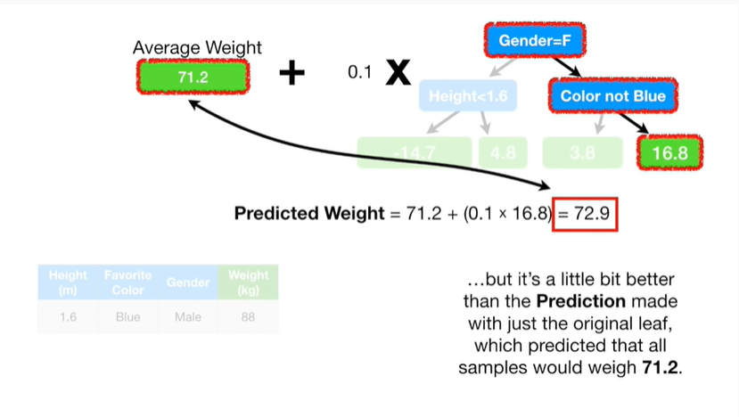

but it's a little better than the prediction made with just the original leaf which predicted that all samples would weigh seventy one point two.

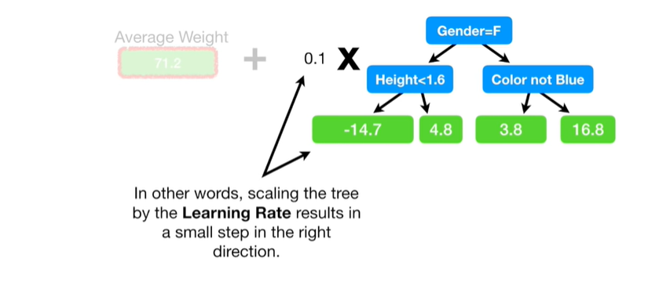

In other words scaling the tree by the learning rate results in a small step in the right direction.

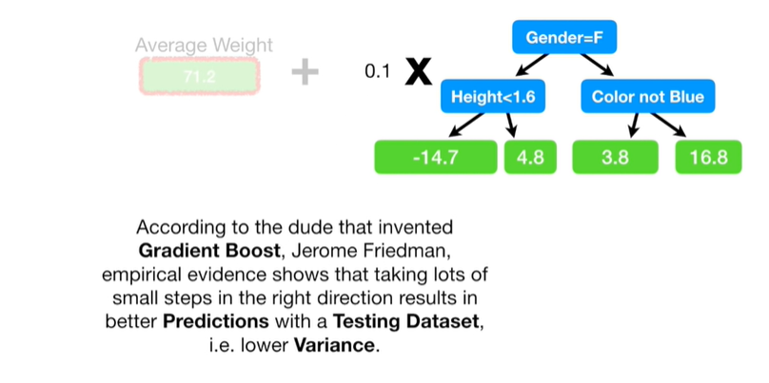

According to the dude that invented gradient boost, Jerome Freedman, empirical evidence shows that taking lots of small steps in the right direction results in better predictions with a testing data set ie lower variance.

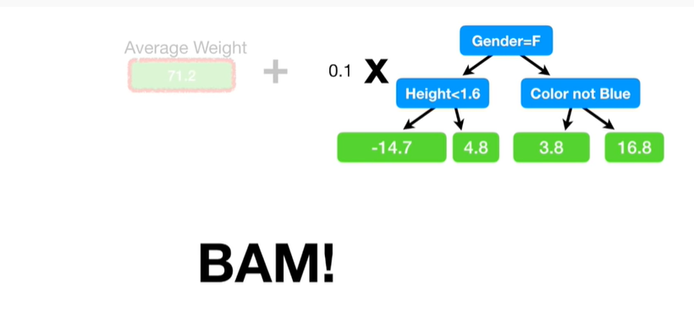

BAM !!!

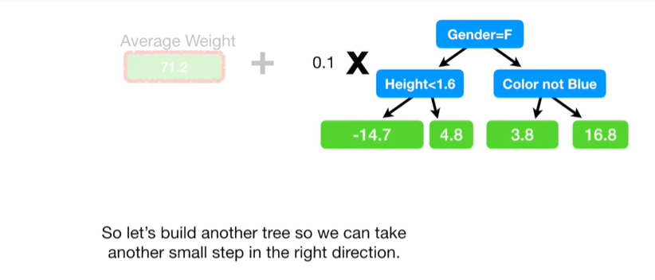

So let's build another tree so we can take another small step in the right direction.

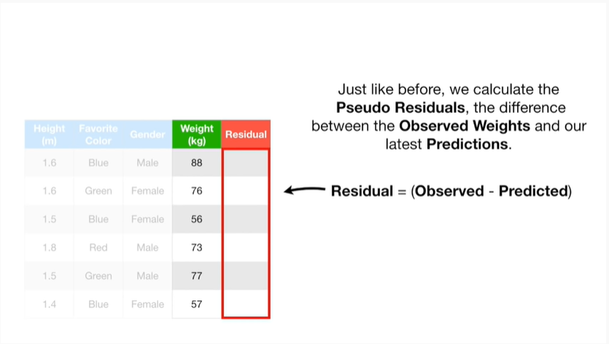

Just like before we calculate the pseudo residuals the difference between the observed weights and our latest predictions.

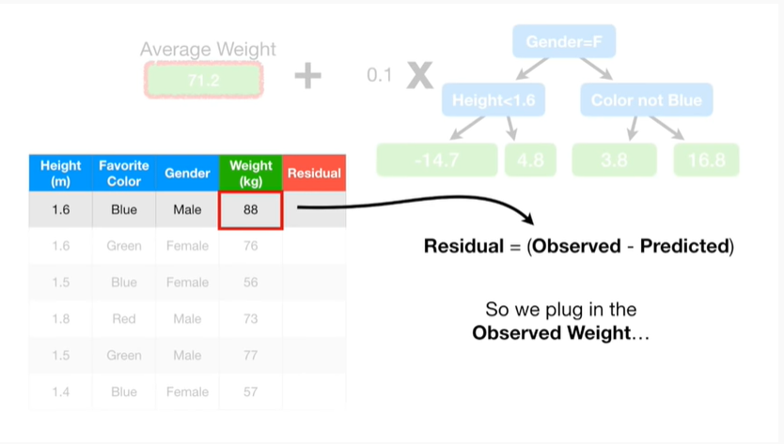

So we plug in the observed weight

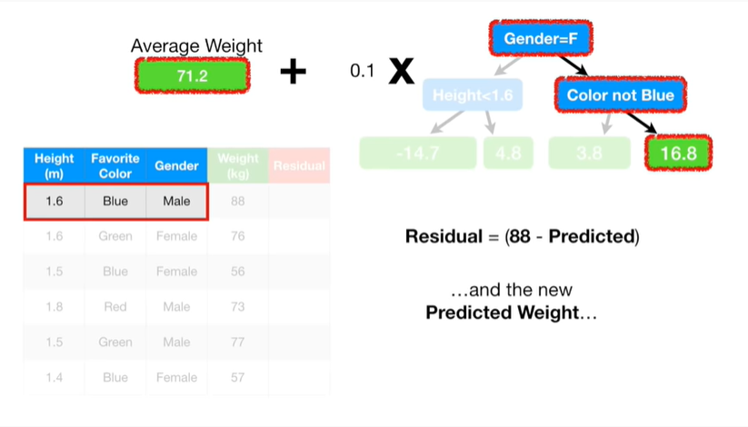

and the new predicted weight

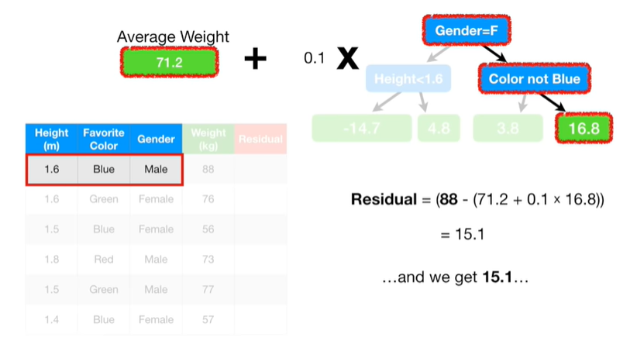

and we get 15.1

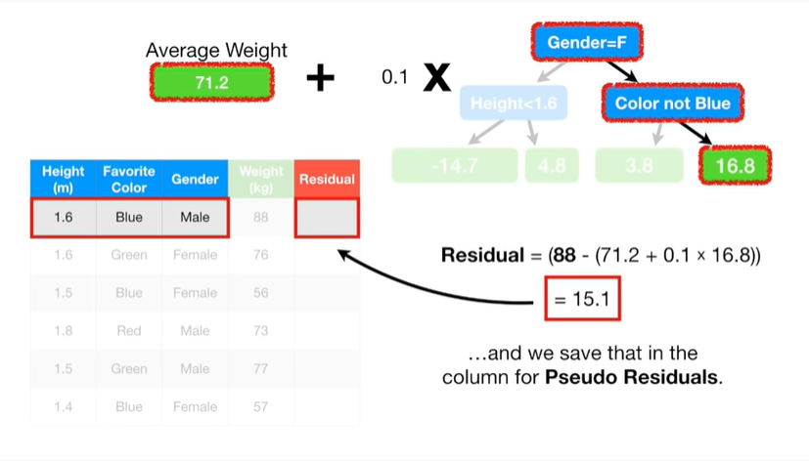

and we save that in the column for pseudo residuals.

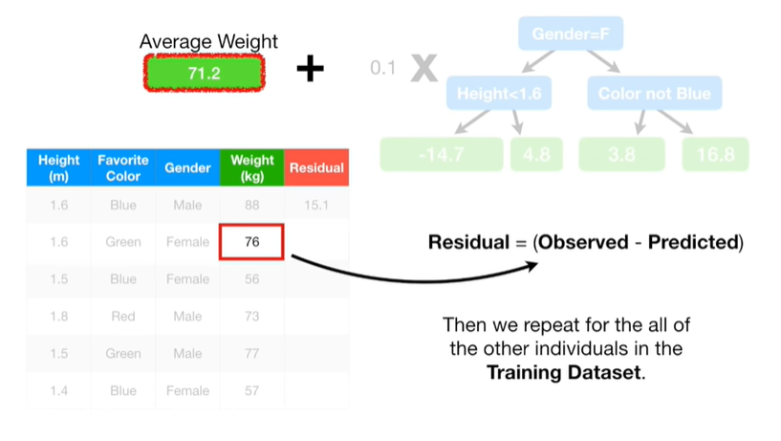

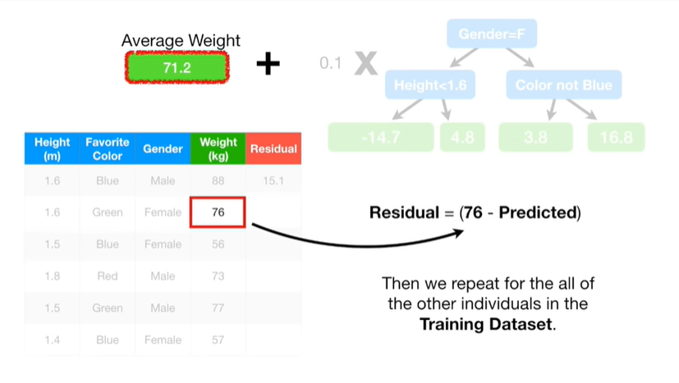

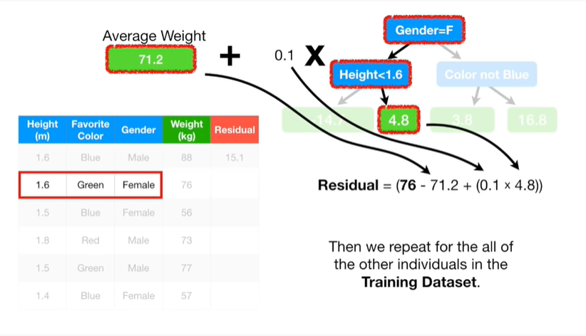

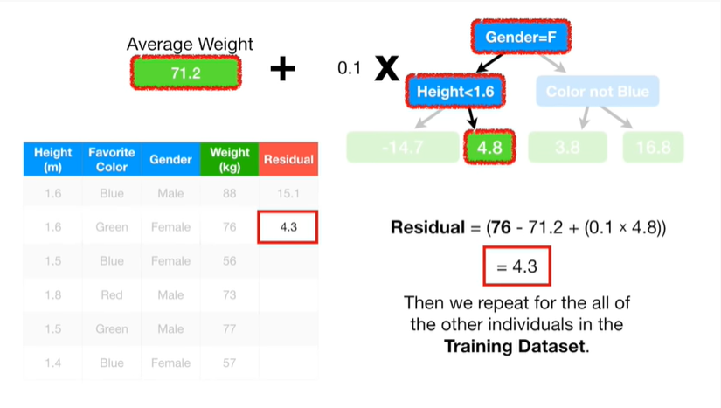

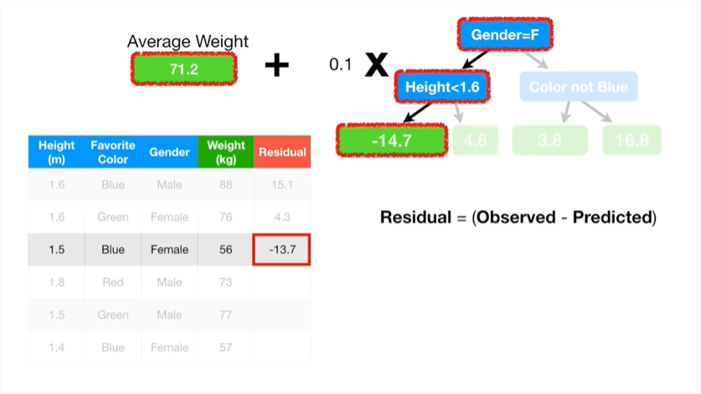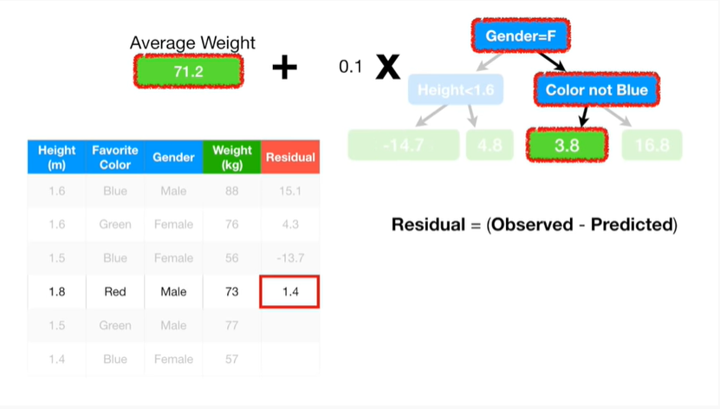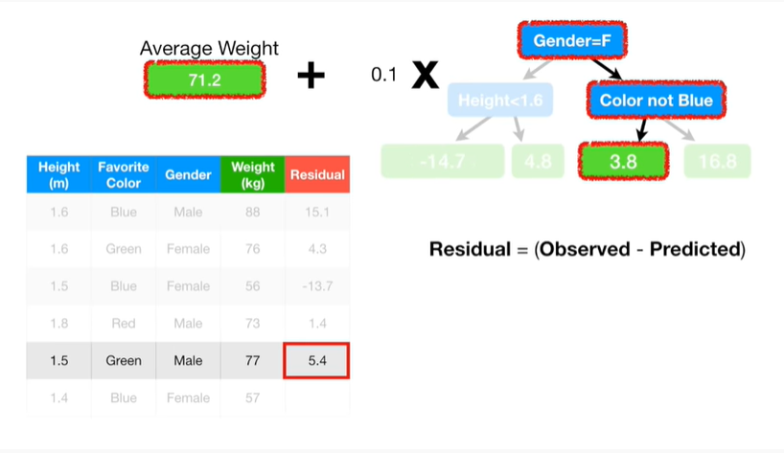

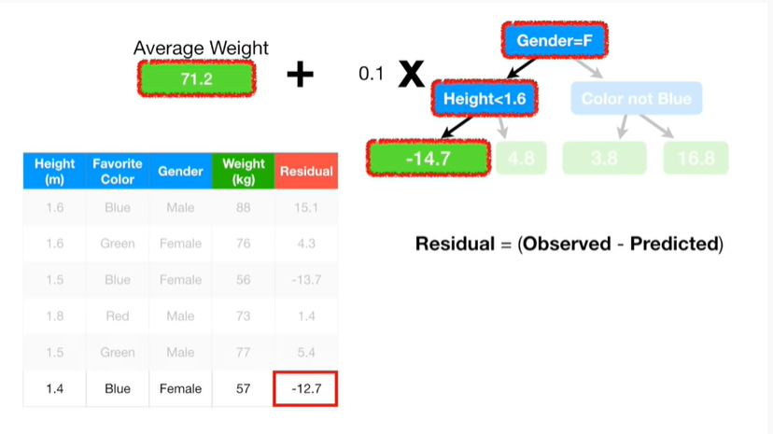

Then we repeat for all of the other individuals in the training data set.

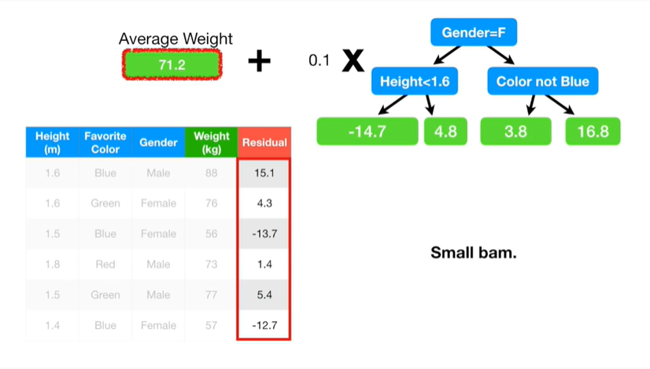

Small BAM.

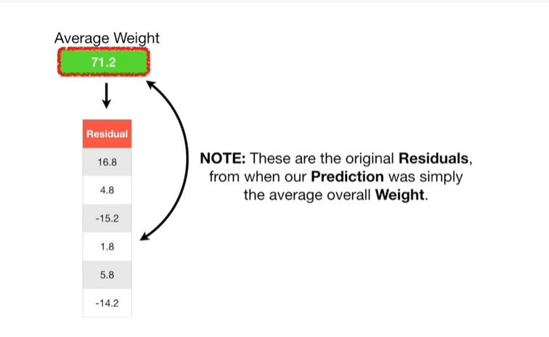

Note : these are the original residuals, from when our prediction was simply the average overall weight

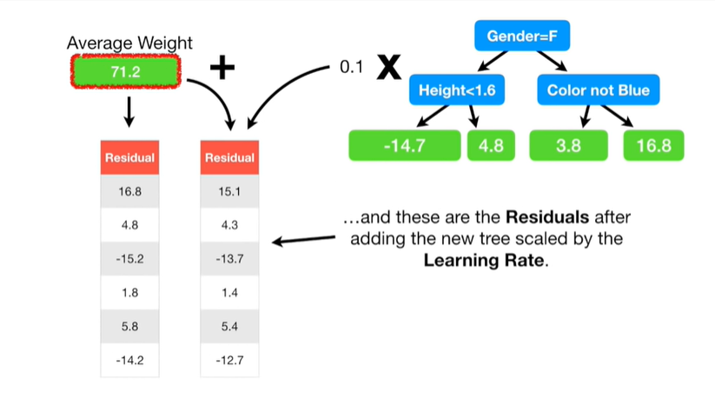

and these are the residuals after adding the vew tree scaled by the learning rate.

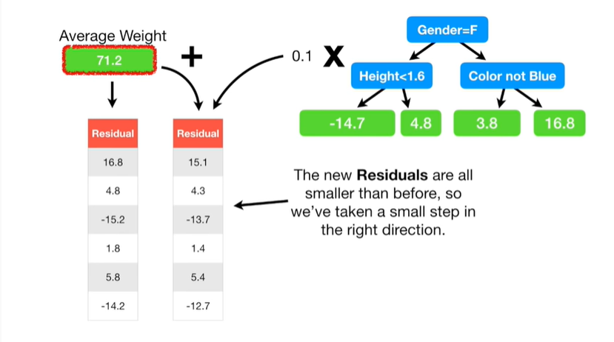

The new residuals are all smaller than before, so we've taken a small step in the right direction.

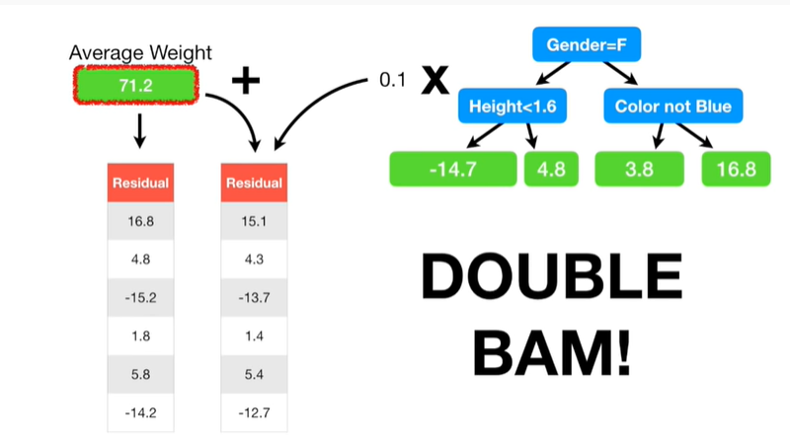

Double bam !!!

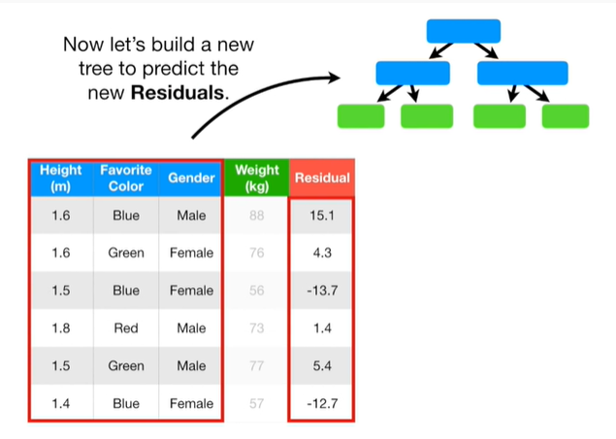

Now let's build a new tree to predict the new residuals.

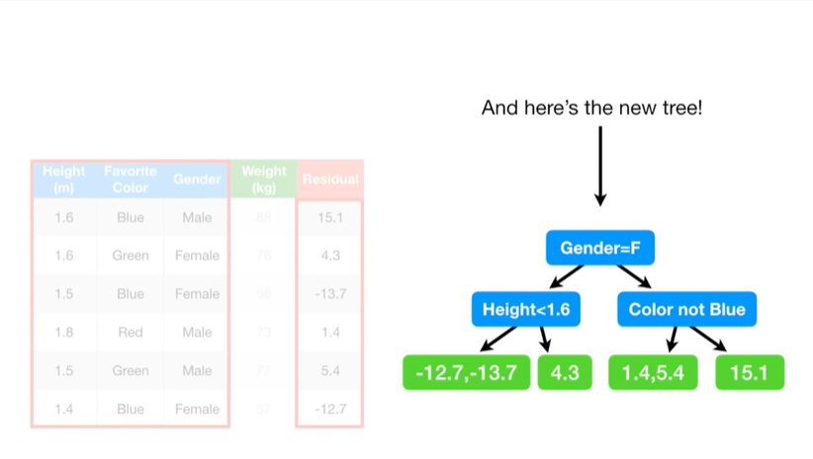

And here's the new tree.

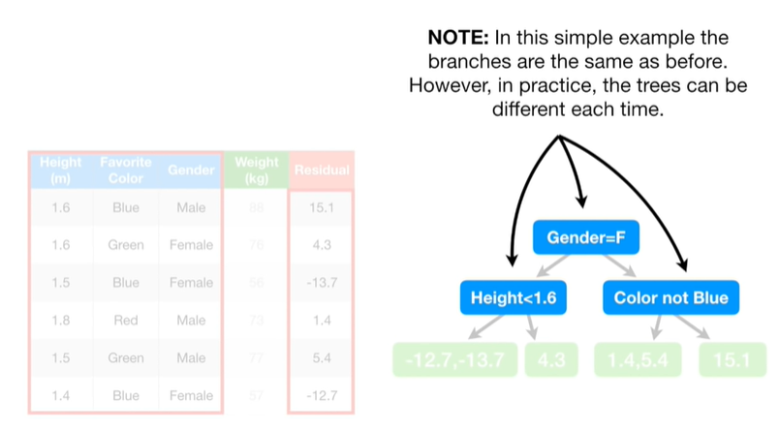

Note : in this simple example the branches are the same as before.

However, in practice, the trees can be different each time.

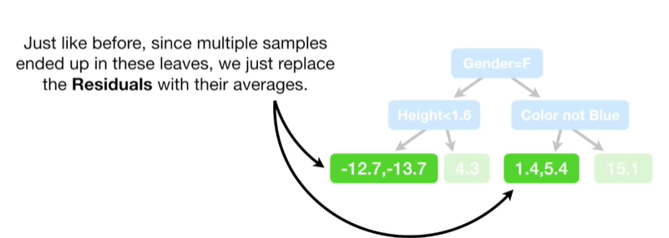

Just like before since multiple samples ended up in these leaves we just replace the residuals with their averages.

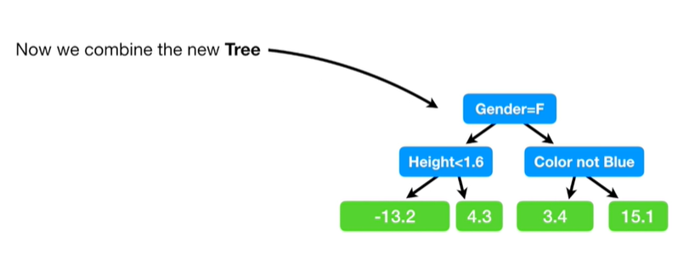

Now we combine the new tree with the previous tree

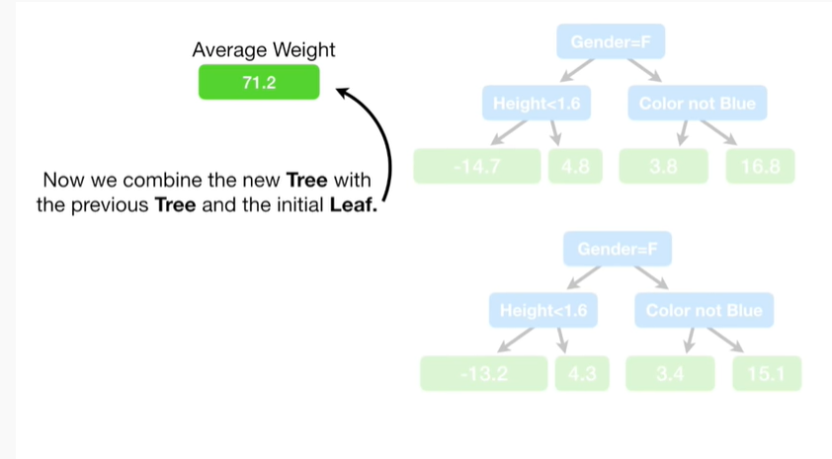

and the initial leaf.

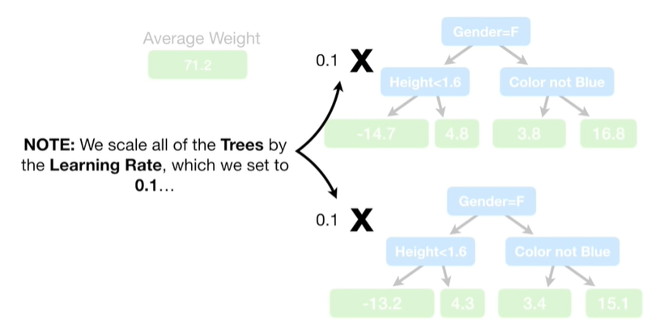

Note : we scale all of the trees by the learning rate, which we set to 0.1

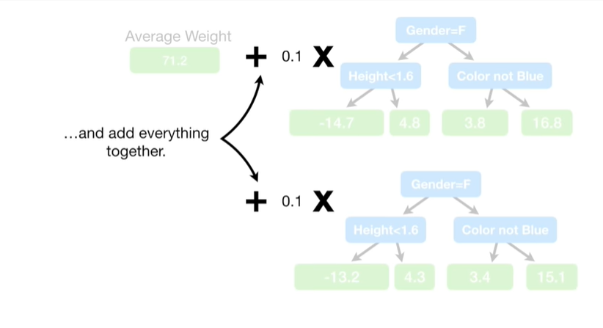

and add everything together.

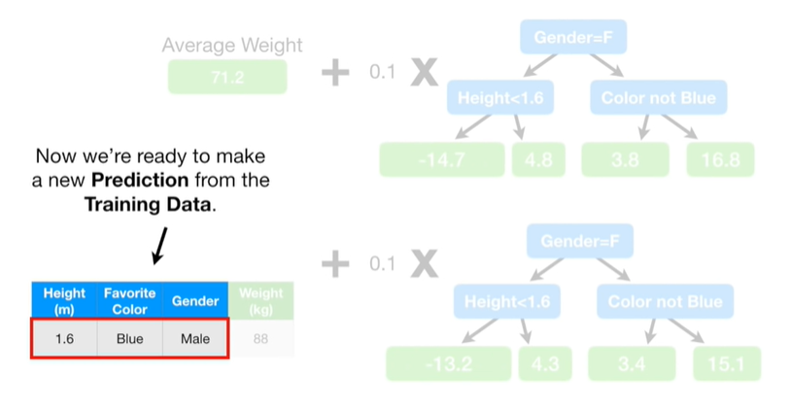

Now we're ready to make a new prediction from the training data.

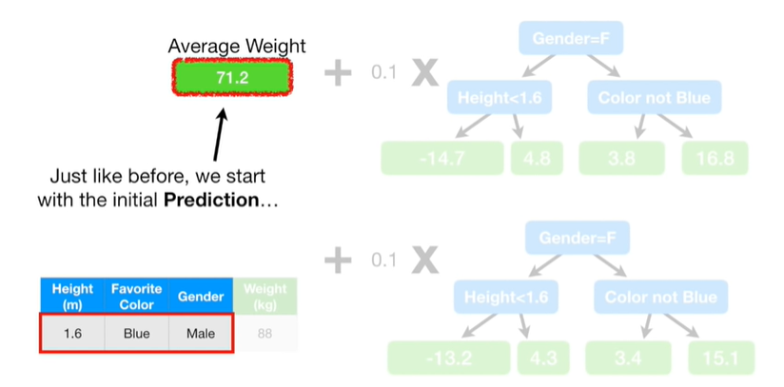

Just like before we start with the initial prediction

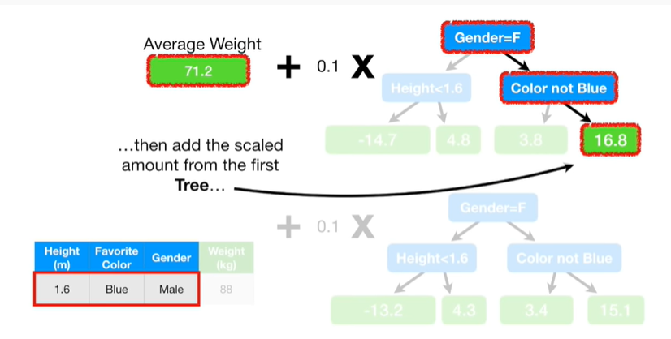

then add the scaled amount from the first tree

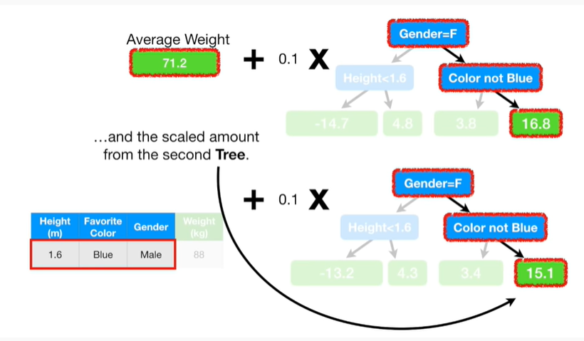

and the scaled amount from the second tree.

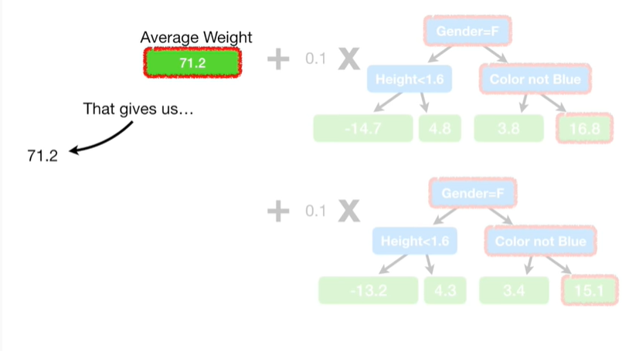

That gives us seventy one point two

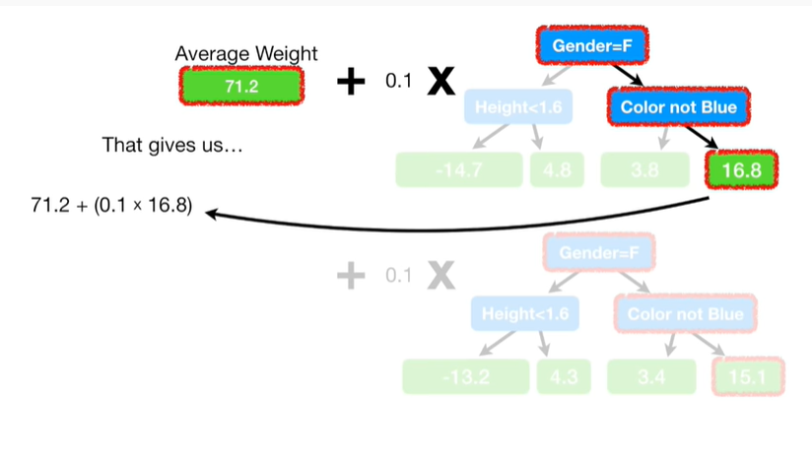

plus zero point one times sixteen point eight

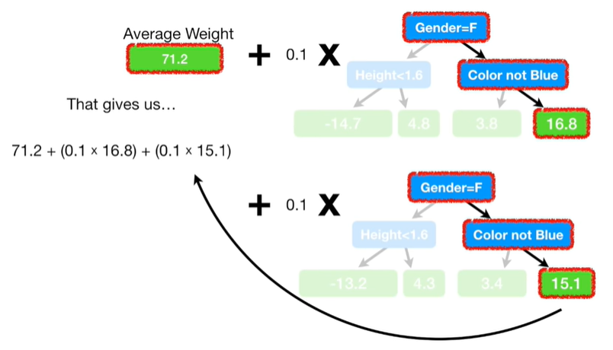

plus zero point one times fifteen point one

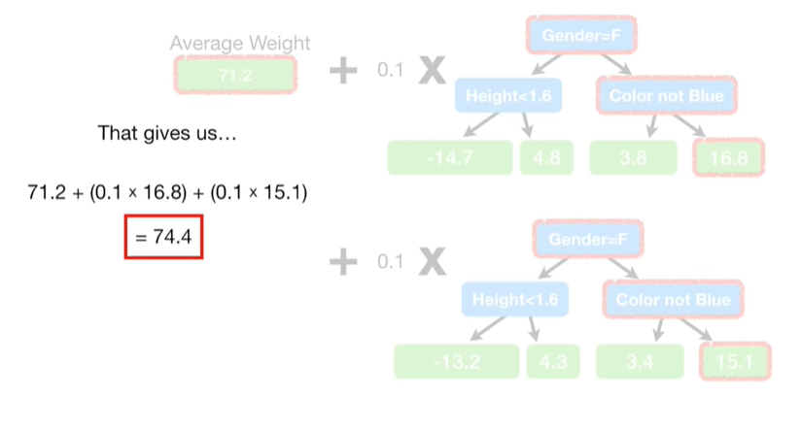

which equals seventy four point four.

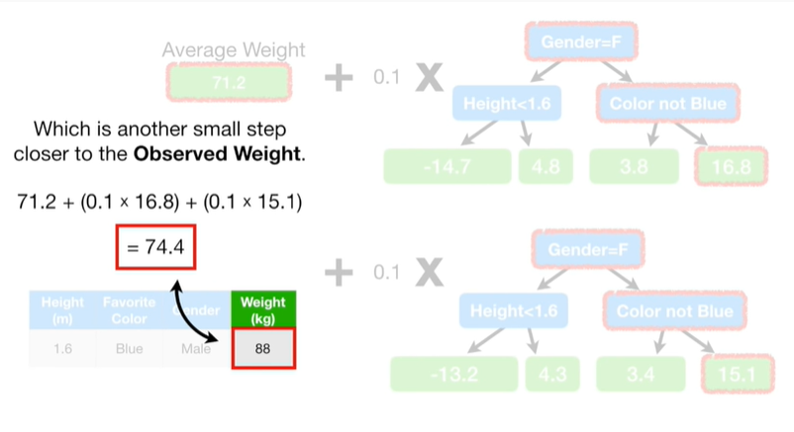

Which is another small step closer to the observed weight.

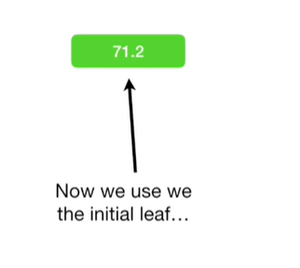

Now we use the initial leaf

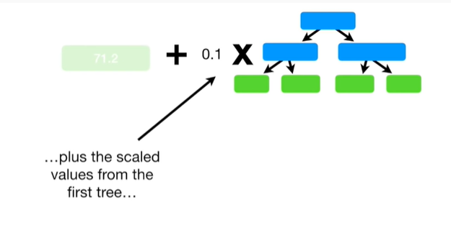

plus the scaled values from the first tree

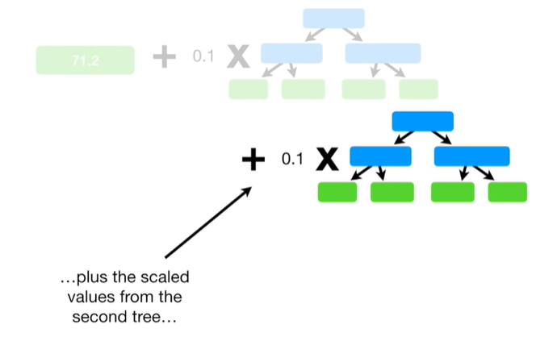

plus the scaled values from the second tree

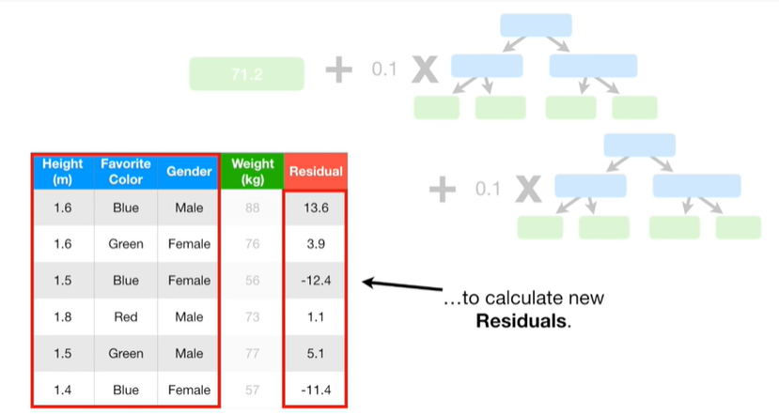

to calculate new residuals.

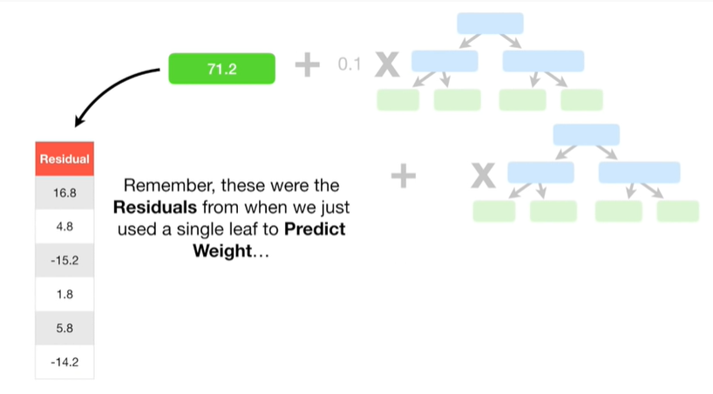

Remember, these were the residuals from when we just use a single leaf to predict weight

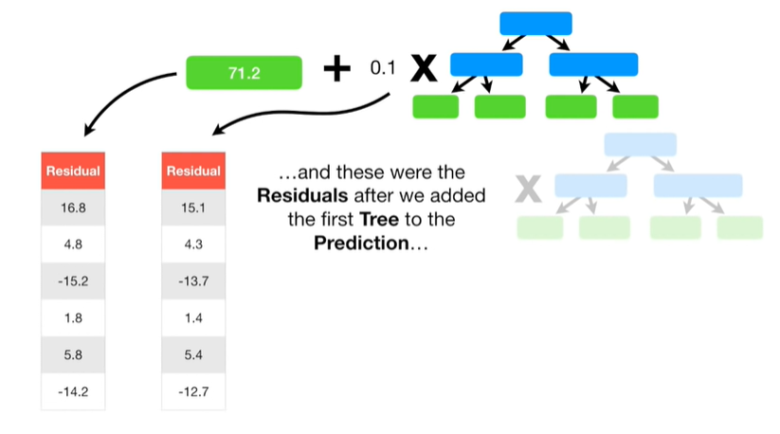

and these were the residuals after we added the first tree to the prediction

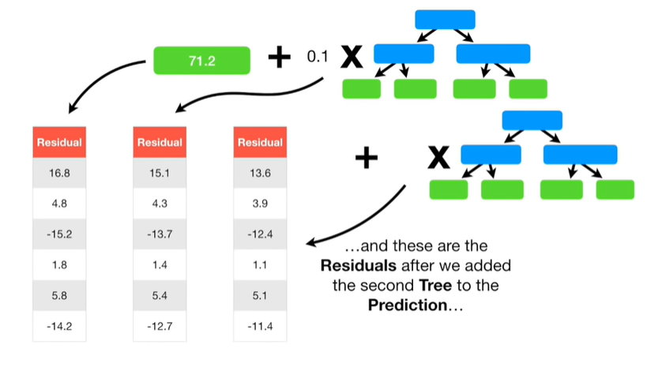

and these are the residuals after we added the second tree to the prediction.

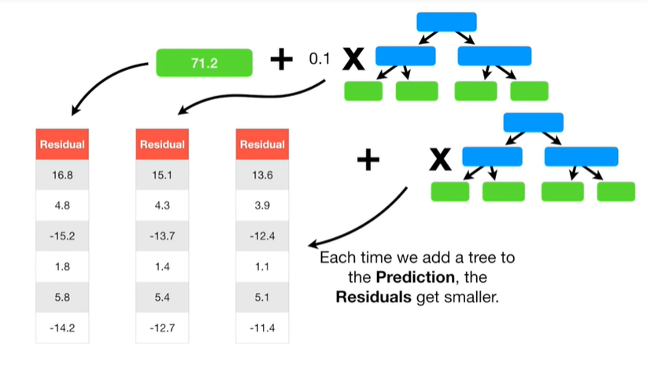

Each time we add a tree to the Prediction, the residuals get smaller.

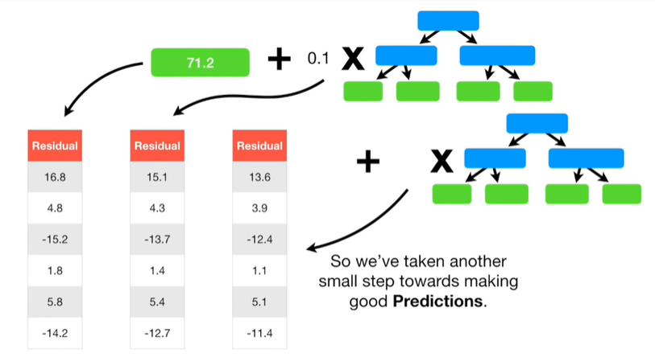

So we've taken another small step towards making good predictions.

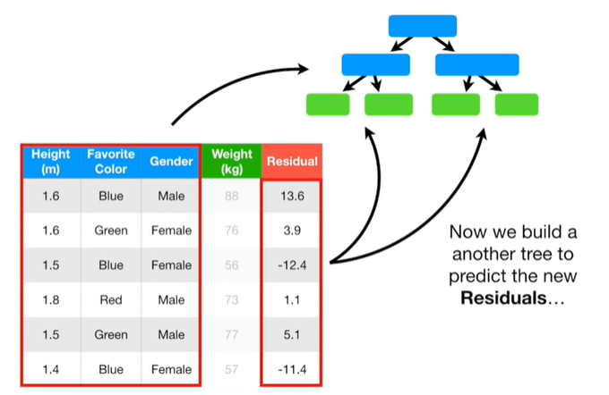

Now we build another tree to predict the new residuals

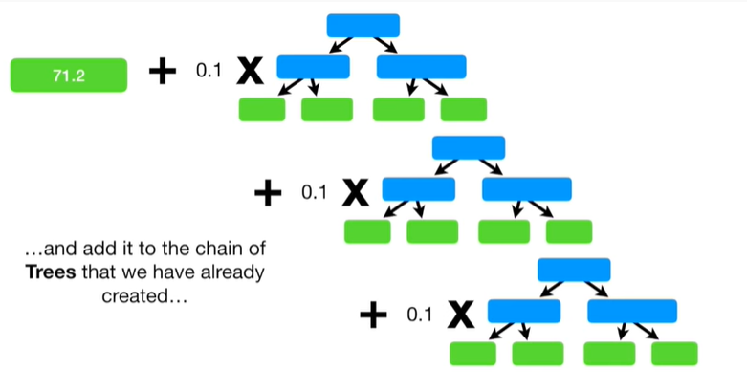

and add it to the chain of trees that we have already created

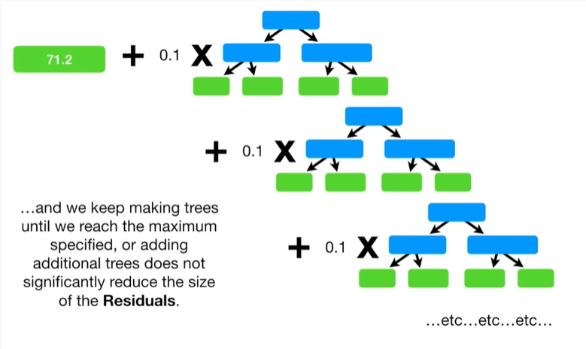

and we keep making trees until we reach the maximum specified or adding additional trees does not significantly reduce the size of the residuals.

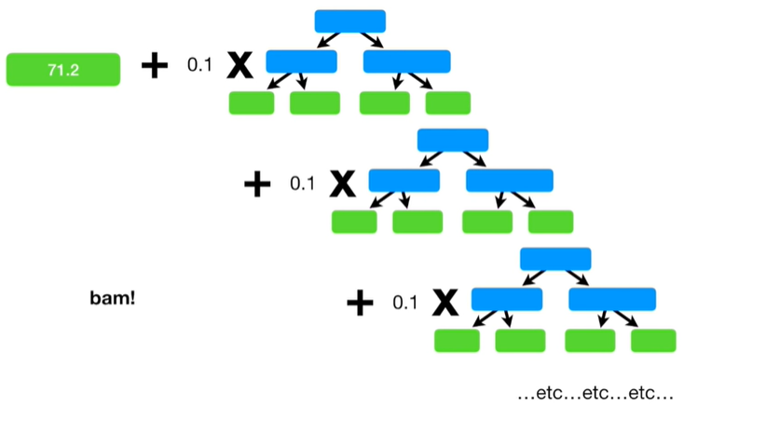

BAM !!!

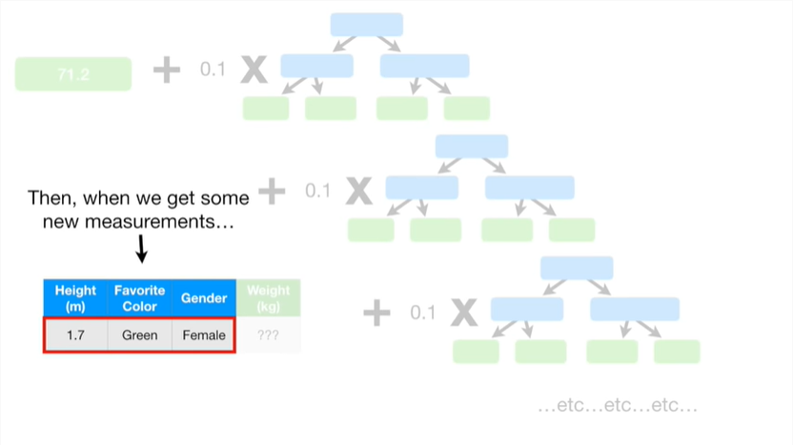

Then when we get some new measurements

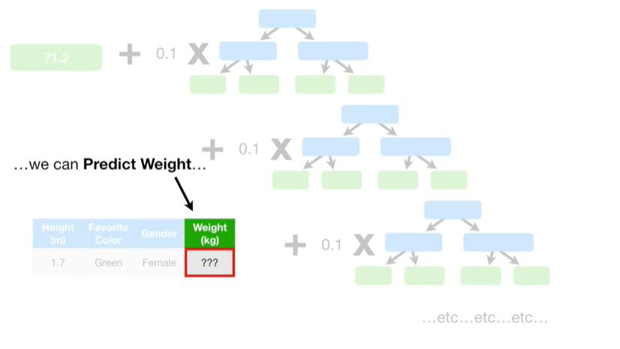

we can predict weight.

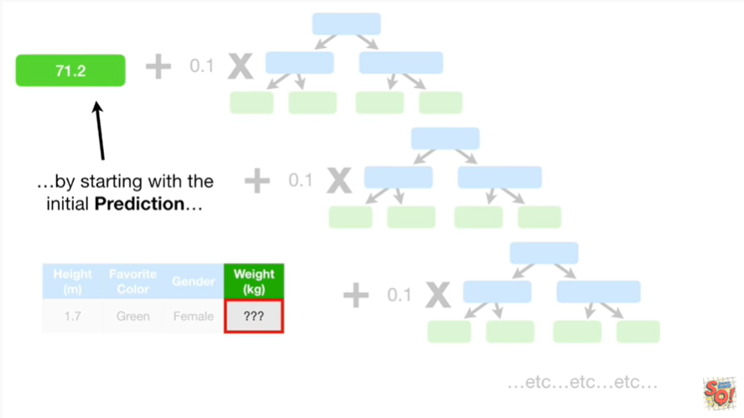

By starting with the initial prediction

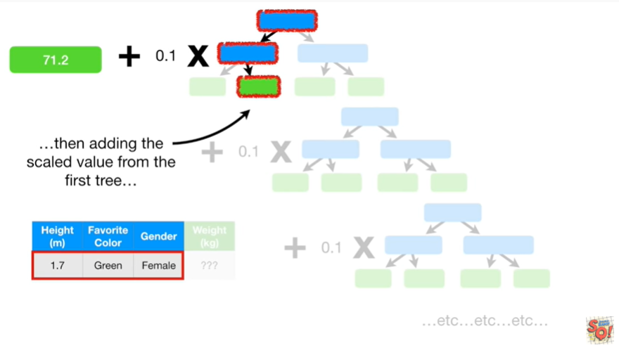

then adding the scaled value from the first tree

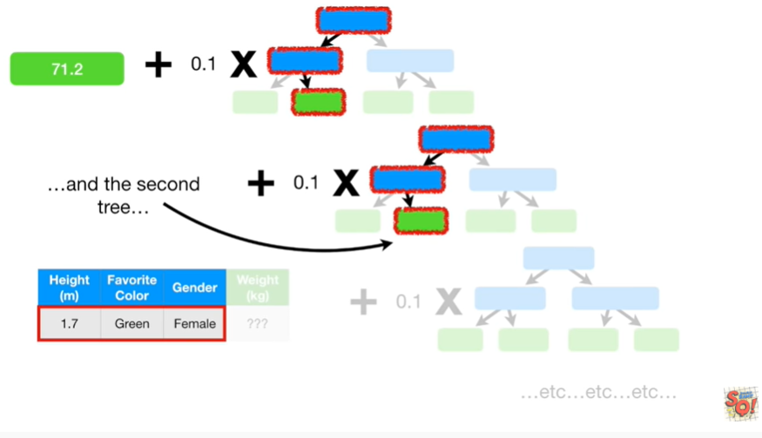

and the second tree

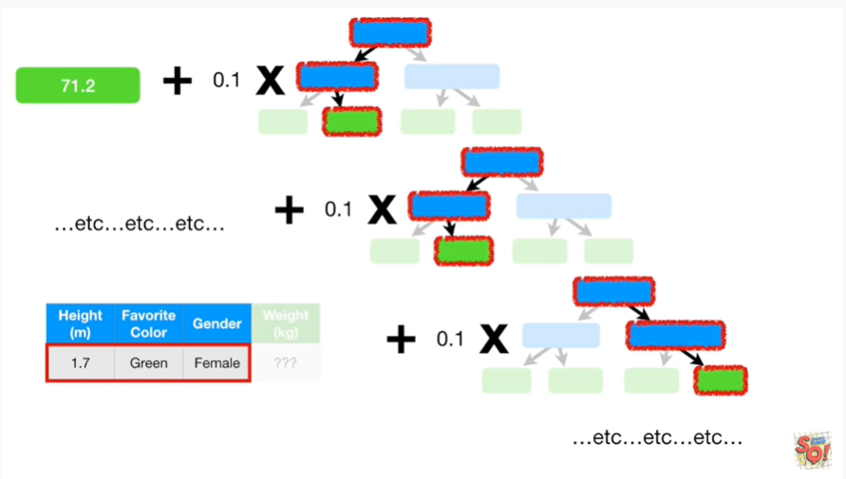

and the third tree etc etc etc

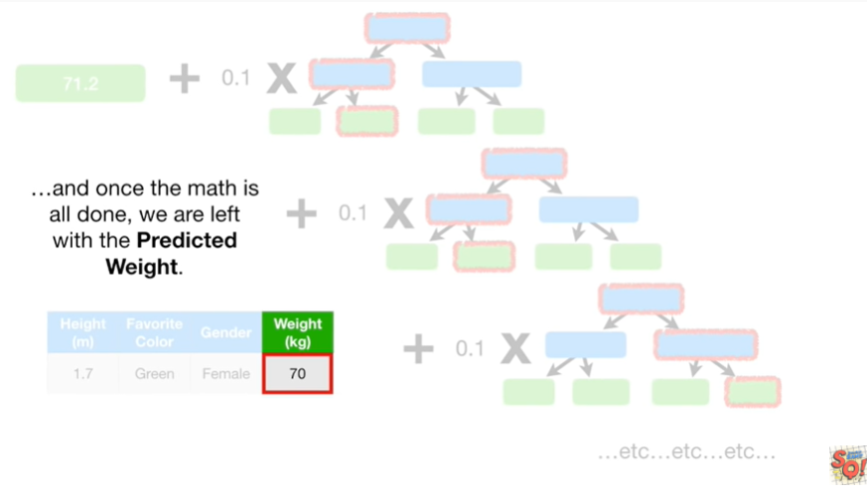

and once the math is all done we are left with the predicted weight.

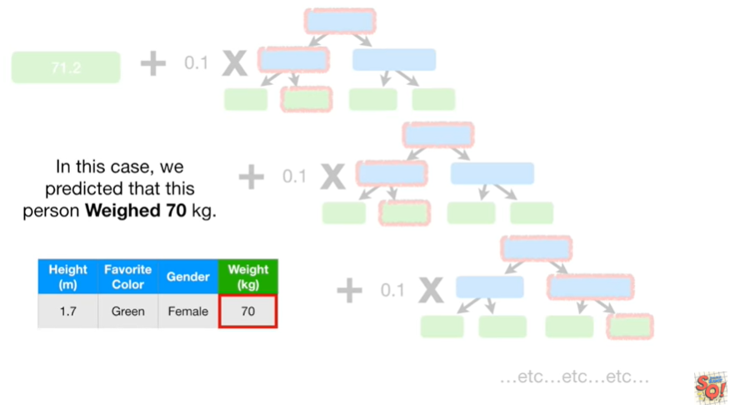

In this case we predicted that this person weighed 70 kilograms.



Triple BAM !!!



In summary, when gradient boost is used for regression

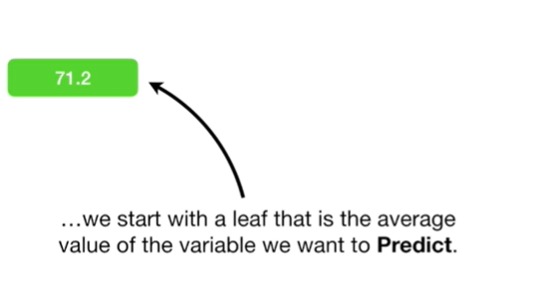

we start with a leaf that is the average value of the variable we want to predict.

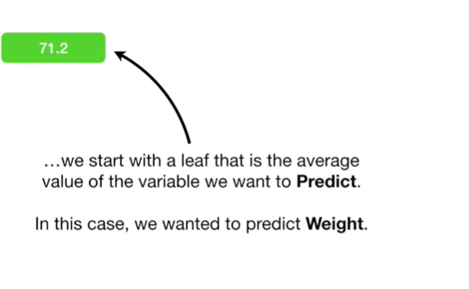

In this case we want it to predict weight.

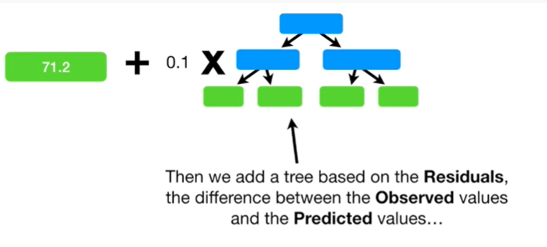

Then we add a tree based on the residuals the difference between the observed values and the predicted values

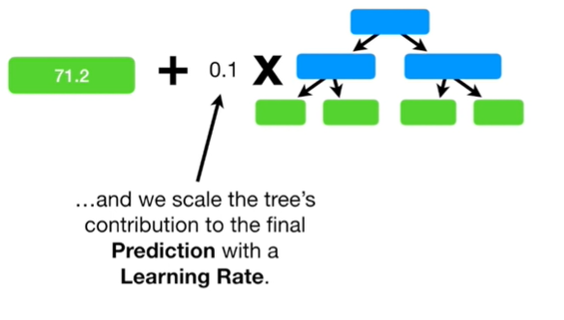

and we scale the trees contribution to the final prediction with a learning rate.

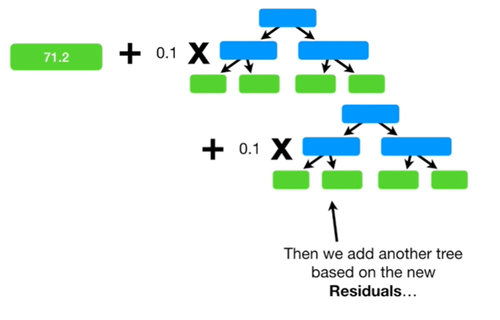

Then we add another tree based on the new residuals

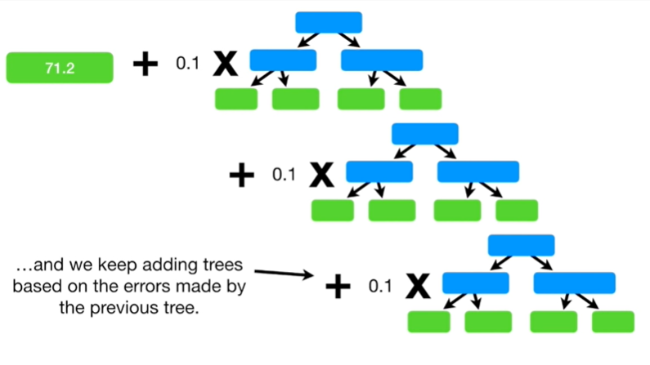

adding trees based on the errors made by the previous tree.

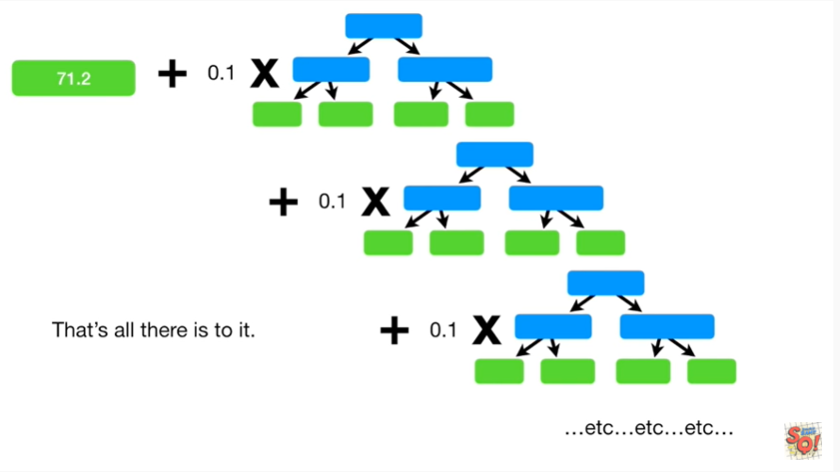

That's all there is to it.

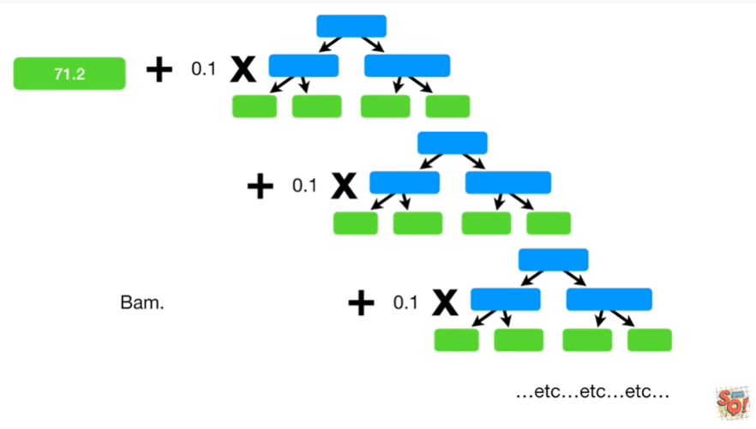

BAM.

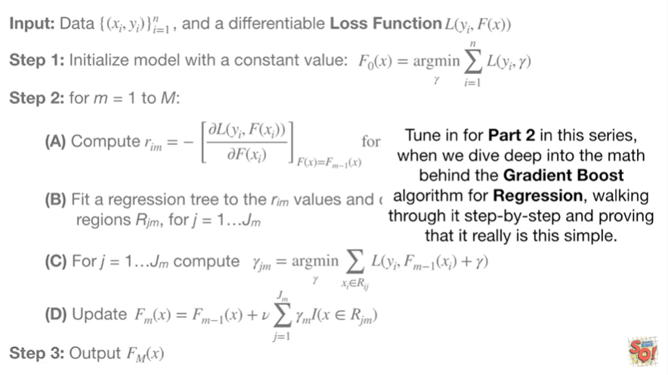

Tune in for part 2 in this series, when we dive deep into the math behind the gradient boost algorithm for regression, walking through it's step by step and proving that it really is this simple.